**DEWAN INSTITUTES OF MANAGEMENT STUDIES**



**MAJOR PROJECT**

**REPORT ON**

**AUTOMIZATION**

**OF**

**EXAMINATION**

**SYSTEM**

**Submitted To: Submitted by:**

**(2100740140038)**

**Mr. Ravi Sikka Kunal Kumar**

**Acknowledgement**

I express my sincere gratitude and thanks to **Dewan Institute of Management Studies** for providing me this opportunity to perform my project.

No project is created entirely by an individual. Many people have helped to create this project and each of their contribution has been valuable. The timely completion of this project is mainly due to the interest and persuasion of my Project Coordinator who is not only a guide but a good teacher also.

My sincere thanks to **Mr. Ravi Sikka (Project Coordinator)** for allowing me to work on and to facilitate in pursuing this project.

I would like to thank to all other individual who have contributed directly or indirectly to the success of this project.

Thank you.

**Kunal Kumar**

**INDEX**

|  |  |  |
| --- | --- | --- |
| **Sr. No.** | **Content** | **Page No.** |
| **1** | **Title of the Project** | **01** |
| **2** | **Introduction & Objective** | **02** |
| **3** | **Tools & Environment Used** | **03** |
| **4** | **Analysis:**   1. **CFD** 2. **DFD’s** 3. **E-R Diagram** | **04-11** |
| **5** | **Modules:**   1. **No. of modules** 2. **Process logic of each module** | **12-13** |
| **6** | **Data Structure** | **14-15** |
| **7** | **Program Code** | **16-97** |
| **8** | **Input & Output Screen** | **98-106** |
| **9** | **Testing & Limitations** | **107-108** |
| **10** | **Future Scope of the Project** | **109** |
| **11** | **Bibliography** | **110** |

**TITLE: -**

**Automization of Examination**

**System**

**(*Techno meter*)**

**Introduction:**

In this examination system, the examination activities are conducted in an automized way. The whole examination process is automated, starting from preparing the question papers of various subject by the teachers till the calculations of results of students. The life of both teachers and students has become very easy by the introduction of this system. It also offers security as each teacher or student has a secure username and password for accessing the system. Every student will get question paper in different sequence, so there will be no chance of cheating and the question paper cannot be leaked. The result produced are unbiased as they are computed by the system.

**Objective:**

The main objective of this project is to develop an online examination system for the ease of student. Though online examination we have saved the time expanding between paper and result. Online examination system is the system that allows user to take online test and automatically generates result on answer marked by user.

* Online Examination will reduce the work done by teachers, administrators and students also.
* Responses by the candidates are going to be checked automatically and instantly.
* Reduces paper work.
* Results will show immediately that reduces student anxiety.
* Can be used anywhere, anytime.
* The arrangement of question will be random, so that no one can cheat.

**Tools / Environment Used:**

* **Hardware Tools (Minimum): -**
* Processor: Intel core 2 Quad Q 6700
* RAM: 1GB
* Hard Disk Drive: 120GB
* **Hardware Tools (Recommended): -**
* Processor: Intel core i3-6100U
* RAM: 4GB
* Hard Disk Drive: 500GB
* **Software Tools: -**
* Operating System: Windows XP and above, Linux
* Front End tool:
* JDK 1.8 and above
* Back End tool:
* MySQL
* Editor:
* Notepad

**Analysis:**

1. **Context Free Diagram: -**

**Login Details**

**Technology Details**

**Question Details**

**Reports**

**Examination Details**

**Registration Details**

1. **Level DFD: -**

**USER**

**USER**

**TECHNOLOGY**

**TECHNOLOGY**

**QUESTION**

**TECHNOLOGY**

**REGISTRATION**

**REGISTRATION**

**QUESTION**

**INVALID**

**User id/ pwd**

**RESULTS**

**VALID**

**RESULT**

**1-level DFD for Login Process: -**

**USER**

**USER**

**USER**

**USER**

**LOGIN**

**CHANGE PASSWORD**

**REMOVE USER**

**VALID**

**INVALID**

**SIGN IN/ UP**

**1-Level DFD for Technology Details: -**

**USER**

**TECHNOLOGY**

**TECHNOLOGY**

**TECHNOLOGY**

**ADMIN/USER**

**INVALID**

**ID/PWD**

**VALID**

**1-Level DFD for Question Details: -**

**USER**

**USER**

**TECHNOLOGY**

**QUESTION**

**TECHNOLOGY**

**QUESTION**

**TECHNOLOGY**

**QUESTION**

**LOGIN**

**NEW QUESTION**

**MODIFY QUESTION**

**DELETE QUESTION**

**INVALID**

**ID/PWD**

**VALID**

**1-Level DFD for Registration Details: -**

**USER**

**USER**

**TECHNOLOGY**

**REGISTRATION**

**REGISTRATION**

**REGISTRATION**

**NEW REGISTRATION**

**MODIFY REGISTRATION**

**CANCEL REGISTRATION**

**USER ID/ PWD**

**1-Level DFD for Examination Detail: -**

**USER**

**REGISTRATION**

**QUESTION**

**RESULT**

**USER**

**LOGIN**

**EXAMINATION**

**VALID**

**INVALID**

**ID/PWD**

**E-R Diagram: -**

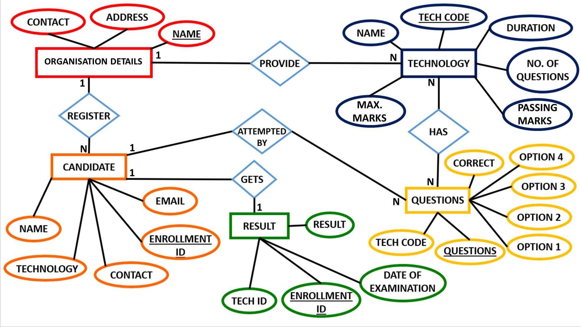

**Admin**

**HAS**

**TECH ID**

**Modules:**

* **Number of modules**
* **Process logic of each module**

1. **Number of modules:**

In this project there will be number of modules as follows:

1. **Login module**
2. **Technology details module**
3. **Question details module**
4. **Registration details module**
5. **Examination details module**
6. **Report module**
7. **Process logic of each module:**
8. **Process logic of login module:**

**This module may comprise of following two types of user:**

* + - * 1. User
        2. Administrator

**User module** may comprise of following tasks –

1. Registration of new student
2. Modification of registration details
3. Cancellation of registration
4. Appearing in the examination
5. Change password

The **administrator module** will perform administrative task such as maintaining technologies details, question details, & change password.

1. **Process logic of technologies details module:**

**This module may comprise of following task -**

1. Addition of new-technology details
2. Modification of existing technology details
3. Deletion of any existing technology
4. **Process logic of question details module:**

**This module may comprise of following two types of task: -**

1. Addition of new questions
2. Modification of existing questions
3. Deletion of any existing questions
4. **Process logic of registration details module**

**This module may comprise of following two types of task: -**

1. Addition of new user
2. Modification schedule of an examination
3. Cancellation of an examination
4. **Process logic of examination module:**

**This module may comprise of following two types of task: -**

1. Conduction of an examination
2. Declaring result
3. **Project logic of report module**

**In this module, following types of reports will be generated:**

1. List of all technologies
2. List of all registered students
3. List of all students technology-wise
4. List of all students with their result

**Data Structure: -**

**Admin: -**

|  |  |  |  |  |  |
| --- | --- | --- | --- | --- | --- |
| S No. | Fieldname | Datatype | Size | Constraint | Description |
| 1 | admin | Varchar | 30 | Primary key | --- |
| 2 | admin_pass | Varchar | 50 | Not Null | --- |

**Organisational Details: -**

|  |  |  |  |  |  |
| --- | --- | --- | --- | --- | --- |
| S No. | Fieldname | Datatype | Size | Constraint | Description |
| 1 | Name | Varchar | 30 | Primary key | --- |
| 2 | Address | Varchar | 50 | Not Null | --- |
| 3 | Contact | Varchar | 11 | Not Null | --- |

**Technology: -**

|  |  |  |  |  |  |
| --- | --- | --- | --- | --- | --- |
| S No. | Fieldname | Datatype | Size | Constraint | Description |
| 1 | Tech_code | Integer | 11 | Primary Key | Technology code |
| 2 | Tech_name | Varchar | 40 | Not Null | Technology name |
| 3 | N_O_Q | Integer | 11 | Not Null | No. of Questions |
| 4 | Max_Marks | Integer | 11 | Not Null | Maximum Marks |
| 5 | Pass_marks | Integer | 11 | Not Null | Passing Marks |
| 6 | Duration | Integer | 11 | Not Null | **Time Duration** |

**Questions: -**

|  |  |  |  |  |  |
| --- | --- | --- | --- | --- | --- |
| S No. | Fieldname | Datatype | Size | Constraint | Description |
| 1 | Question | Varchar | 500 | Primary key | --- |
| 2 | Tech_code | Integer | 11 | Primary key | Technology code |
| 3 | Option_1 | Varchar | 30 | Not Null | --- |
| 4 | Option_2 | Varchar | 30 | Not Null | --- |
| 5 | Option_3 | Varchar | 30 | Not Null | --- |
| 6 | Option_4 | Varchar | 30 | Not Null | --- |
| 7 | Correct_opt | Varchar | 30 | Not Null | Correct option |
| 8 | Tech_name | Varchar | 30 | Not Null | --- |

**Candidate: -**

|  |  |  |  |  |  |
| --- | --- | --- | --- | --- | --- |
| S No. | Fieldname | Datatype | Size | Constraint | Description |
| 1 | Enrollment_no | Integer | 11 | Primary key | Enrollment number |
| 2 | Name | Varchar | 30 | Not Null | --- |
| 3 | Contact | Varchar | 10 | Not Null | --- |
| 4 | Gender | Varchar | 20 | Not Null | --- |
| 5 | Technology | Varchar | 30 | Not Null | --- |
| 6 | DOB | Varchar | 11 | Not Null | --- |
| 7 | DOE | Varchar | 11 | Not Null | --- |
| 8 | Email | Varchar | 50 | Not Null | --- |

**Result: -**

|  |  |  |  |  |  |
| --- | --- | --- | --- | --- | --- |
| S no. | Fieldname | Datatype | Size | Constraint | Description |
| 1 | Tech_code | Integer | 11 | Primary key | Technology code |
| 2 | Enrollment_no | Integer | 11 | Primary key | Enrollment number |
| 3 | D_O_E | Varchar | 15 | Not Null | Date of Examination |
| 4 | Result | Integer | 11 | Primary key | --- |

**Program Code:**

**Login:**

|  |  |
| --- | --- |
| import javax.swing.*;  import java.awt.*;  import java.sql.*;  import java.awt.event.*;  class Login_Demo extends JFrame implements  ActionListener, MouseListener {  JLabel  lmain,lm1,pnl1_bg,pnl2_bg,limg1,limg2,limg3  ,limg4,limg5,limg6,lm2,lm3,  lm4,lm6,la1,la2,la3,ls1,ls2,ls3,bg;  JTextField ta1,ts1;  JTextArea tpnl,lm5;  JPasswordField ta2,ts2;  JButton ba1,ba2,bs1,bs2;  Container c;  JPanel p1,p2,p3;  Connection con;  PreparedStatement st;  ResultSet rs;  int en;  String sname,spw,nmad,pwad,pwd,pws;  Login_Demo() {  setTitle("Technometer");  setSize(1200,700);  setResizable(false);  setDefaultCloseOperation(EXIT_ON_CLOSE);  setLocationRelativeTo(null);  c=getContentPane();  c.setLayout(null);  Font fmain=new Font  ("Showcard Gothic",Font.BOLD,72);  Font fm1=new Font  ("Monotype Corsiva",Font.BOLD,28); | Font ft1=new Font  ("Lucida Handwriting",Font.BOLD,28);  Font ft2=new Font("Magneto",Font.BOLD,28);  Font ft3=new Font("consolas",Font.BOLD,28);  /*Main Frame*/  ImageIcon im1=new ImageIcon  ("lgn_bg.png");  bg=new JLabel(im1);  bg.setBounds(0,0,1200,730);  c.add(bg);  lmain=new JLabel("Technometer");  lmain.setBounds(620,35,700,80);  lmain.setForeground(Color.WHITE);  lmain.setFont(fmain);  bg.add(lmain);  lm1=new JLabel("Welcome,");  lm1.setBounds(50,150,110,30);  lm1.setForeground(Color.WHITE);  lm1.setFont(fm1);  bg.add(lm1);  lm2=new JLabel("Login as :");  lm2.setBounds(120,190,110,30);  lm2.setForeground(Color.RED);  lm2.setFont(fm1);  bg.add(lm2);  ImageIconim2=new ImageIcon("login_admin.png");  limg1=new JLabel(im2);  limg1.setBounds(30,270,220,150);  limg1.addMouseListener(this);  bg.add(limg1);  lm3=new JLabel("Administrator"); |

|  |  |
| --- | --- |
| Font ft1=new Font  ("Lucida Handwriting",Font.BOLD,28);  Font ft2=new Font("Magneto",Font.BOLD,28);  Font ft3=new Font("consolas",Font.BOLD,28);  /*Main Frame*/  ImageIcon im1=new ImageIcon("lgn_bg.png");  bg=new JLabel(im1);  bg.setBounds(0,0,1200,730);  c.add(bg);  lmain=new JLabel("Technometer");  lmain.setBounds(620,35,700,80);  lmain.setForeground(Color.WHITE);  lmain.setFont(fmain);  bg.add(lmain);  lm1=new JLabel("Welcome,");  lm1.setBounds(50,150,110,30);  lm1.setForeground(Color.WHITE);  lm1.setFont(fm1);  bg.add(lm1);  lm2=new JLabel("Login as :");  lm2.setBounds(120,190,110,30);  lm2.setForeground(Color.RED);  lm2.setFont(fm1);  bg.add(lm2);  ImageIconim2=new ImageIcon("login_admin.png");  limg1=new JLabel(im2);  limg1.setBounds(30,270,220,150);  limg1.addMouseListener(this);  bg.add(limg1);  lm3=new JLabel("Administrator"); | lm3.setBounds(50,430,160,30);  lm3.setForeground(new Color(37, 189, 219));  lm3.setFont(fm1);  bg.add(lm3);  ImageIcon im3=new ImageIcon("sprtrvl.png");  limg2=new JLabel(im3);  limg2.setBounds(270,245,30,260);  bg.add(limg2);  ImageIcon im4=new ImageIcon("login_user.png");  limg3=new JLabel(im4);  limg3.setBounds(270,270,220,150);  limg3.addMouseListener(this);  bg.add(limg3);  lm4=new JLabel("Student");  lm4.setBounds(330,430,110,30);  lm4.setForeground(new Color(37, 189, 219));  lm4.setFont(fm1);  bg.add(lm4);  ImageIcon im5=new ImageIcon("sprtrhl.png");  limg4=new JLabel(im5);  limg4.setBounds(10,475,460,30);  bg.add(limg4);  lm5=new JTextArea("Not, Registered yet ?");  lm5.setBounds(50,525,250,80);  lm5.setOpaque(false);  lm5.setLineWrap(true);  lm5.setWrapStyleWord(true);  lm5.setBackground(new Color(0,0,0,0));  lm5.setForeground(Color.RED); |

|  |  |
| --- | --- |
| lm5.setFont(fm1);  bg.add(lm5);  ImageIcon im6=new ImageIcon("adduser.png");  limg5=new JLabel(im6);  limg5.setBounds(300,480,220,150);  limg5.addMouseListener(this);  bg.add(limg5);  lm6=new JLabel("Sign Up");  lm6.setBounds(355,625,150,30);  lm6.setForeground(new Color(37, 189, 219));  lm6.setFont(fm1);  bg.add(lm6);  **//Login as an admin**  p1=new JPanel();  p1.setLayout(null);  p1.setBounds(550,150,600,450);  bg.add(p1);  p1.setVisible(false);  ImageIcon im7=new ImageIcon  ("loginpnl1_bg.png");  pnl1_bg=new JLabel(im7);  pnl1_bg.setBounds(0,0,600,450);  p1.add(pnl1_bg);  la1=new JLabel("Login as Administrator");  la1.setFont(ft1);  la1.setForeground(Color.WHITE);  la1.setBounds(20,50,400,40);  pnl1_bg.add(la1);  la2=new JLabel("Admin Name");  la2.setFont(ft2); | lm5.setFont(fm1);  bg.add(lm5);  ImageIcon im6=new ImageIcon("adduser.png");  limg5=new JLabel(im6);  limg5.setBounds(300,480,220,150);  limg5.addMouseListener(this);  bg.add(limg5);  lm6=new JLabel("Sign Up");  lm6.setBounds(355,625,150,30);  lm6.setForeground(new Color(37, 189, 219));  lm6.setFont(fm1);  bg.add(lm6);  //Login as an admin  p1=new JPanel();  p1.setLayout(null);  p1.setBounds(550,150,600,450);  bg.add(p1);  p1.setVisible(false);  ImageIcon im7=new ImageIcon  ("loginpnl1_bg.png");  pnl1_bg=new JLabel(im7);  pnl1_bg.setBounds(0,0,600,450);  p1.add(pnl1_bg);  la1=new JLabel("Login as Administrator");  la1.setFont(ft1);  la1.setForeground(Color.WHITE);  la1.setBounds(20,50,400,40);  pnl1_bg.add(la1);  la2=new JLabel("Admin Name");  la2.setFont(ft2); |

|  |  |
| --- | --- |
| la2.setForeground(Color.WHITE);  la2.setBounds(50,220,250,30);  pnl1_bg.add(la2);  ta1=new JTextField();  ta1.setFont(ft3);  ta1.setBounds(350,220,200,35);  pnl1_bg.add(ta1);  la3=new JLabel("Password");  la3.setForeground(Color.WHITE);  la3.setFont(ft2);  la3.setBounds(50,290,200,30);  pnl1_bg.add(la3);  ta2=new JPasswordField();  ta2.setFont(ft3);  ta2.setBounds(350,290,200,30);  pnl1_bg.add(ta2);  ba1=new JButton("Submit");  ba1.setBackground(Color.BLACK);  ba1.setForeground(Color.WHITE);  ba1.setFont(ft2);  ba1.addActionListener(this);  ba1.setBounds(80,360,150,35);  pnl1_bg.add(ba1);  ba2=new JButton("Close");  ba2.setBackground(Color.BLACK);  ba2.setForeground(Color.WHITE);  ba2.setFont(ft2);  ba2.addActionListener(this);  ba2.setBounds(360,360,150,35); | l pnl1_bg.add(ba2);  **//Login as a student**  p2=new JPanel();  p2.setBounds(550,150,600,450);  p2.setLayout(null);  bg.add(p2);  p2.setVisible(false);  ImageIcon im8=new ImageIcon  ("loginpnl2_bg.png");  pnl2_bg=new JLabel(im8);  pnl2_bg.setBounds(0,0,600,450);  p2.add(pnl2_bg);  ls1=new JLabel("Login as Student");  ls1.setFont(ft1);  ls1.setForeground(Color.WHITE);  ls1.setBounds(20,50,400,40);  pnl2_bg.add(ls1);  ls2=new JLabel("Student's Name");  ls2.setForeground(Color.WHITE);  ls2.setFont(ft2);  ls2.setBounds(50,220,250,30);  pnl2_bg.add(ls2);  ts1=new JTextField();  ts1.setFont(ft3);  ts1.setBounds(350,220,200,35);  pnl2_bg.add(ts1);  ls3=new JLabel("Password");  ls3.setForeground(Color.WHITE);  ls3.setFont(ft2);  ls3.setBounds(50,290,200,30); |

|  |  |
| --- | --- |
| pnl2_bg.add(ls3);  ts2=new JPasswordField();  ts2.setFont(ft3);  ts2.setBounds(350,290,200,30);  pnl2_bg.add(ts2);  ImageIcon im9=new ImageIcon("hint.png");  limg6=new JLabel(im9);  limg6.setBounds(550,270,50,50);  limg6.addMouseListener(this);  pnl2_bg.add(limg6);  bs1=new JButton("Submit");  bs1.setBackground(Color.BLACK);  bs1.setFont(ft2);  bs1.setForeground(Color.WHITE);  bs1.addActionListener(this);  bs1.setBounds(80,360,150,35);  pnl2_bg.add(bs1);  bs2=new JButton("Close");  bs2.setBackground(Color.BLACK);  bs2.setForeground(Color.WHITE);  bs2.setFont(ft2);  bs2.addActionListener(this);  bs2.setBounds(360,360,150,35);  pnl2_bg.add(bs2);  p3=new JPanel();  p3.setLayout(null);  p3.setBounds(270,140,250,65);  pnl2_bg.add(p3);  p3.setVisible(false); | tpnl=new JTextArea("Enter first four alphabet  of your name and year of birth in password.  If your name consists of less than 4  alphabets then enter your full name and year of birth.");  tpnl.setLineWrap(true);  tpnl.setWrapStyleWord(true);  tpnl.setBounds(0,0,250,65);  p3.add(tpnl);  try {  Class.forName("com.mysql.cj.jdbc.Driver");  con=DriverManager.getConnection("jdbc:mysql://localhost/technometer","root","");}  catch(Exception e) {  System.out.print(e);}  setVisible(true);}  public void mousePressed(MouseEvent me) { }  public void mouseReleased(MouseEvent me) { }  public void mouseClicked(MouseEvent me){  if(me.getSource()==limg1) {  p2.setVisible(false);  p1.setVisible(true);}  if(me.getSource()==limg3) {  p1.setVisible(false);  p2.setVisible(true);}  if(me.getSource()==limg5) {  New_Registration_Demond=new New_Registration_Demo();  dispose();}}  public void mouseEntered(MouseEvent me) {  if(me.getSource()==limg6) {  p3.setVisible(true);}}  public void mouseExited(MouseEvent me) {  if(me.getSource()==limg6) { |

|  |  |
| --- | --- |
| p3.setVisible(false);}}  public void actionPerformed(ActionEvent ae) {  if(ae.getSource()==ba2){  p1.setVisible(false);}  else if(ae.getSource()==bs2) {  p2.setVisible(false);}  else if(ae.getSource()==ba1) {  nmad=ta1.getText();  pwad=ta2.getText();  try {  st=con.prepareStatement("select admin_pass from admin where admin=?");  st.setString(1,nmad);  rs=st.executeQuery();  if(rs.next()) {  pwd=rs.getString("admin_pass");  if(pwad.equals(pwd)) {  Admin_Demo ad=new Admin_Demo();  dispose();}  else {  JOptionPane.showMessageDialog(this,"Invalid Password");}}  else {  JOptionPane.showMessageDialog(this,"Invalid Username");}}  catch(Exception e) {  System.out.print(e);}}  else if(ae.getSource()==bs1) {  sname=ts1.getText();  spw=ts2.getText();  try {  st=con.prepareStatement("select dob,enrollment_no from candidate where name=?"); | st.setString(1,sname);  rs=st.executeQuery();  if(rs.next()) {  en=rs.getInt("Enrollment_No");  String dob=rs.getString("DOB");  if(sname.length()>=4){String sn=sname.substring(0,4);  pws= sn.toUpperCase() +dob.substring(7);}  else {  pws= sname.toUpperCase() +dob.substring(7);}  if(spw.equals(pws)) {  Student_Demo sd=new Student_Demo(en);  dispose();}  else {  JOptionPane.showMessageDialog(this,"Invalid Password");  }}  else {  JOptionPane.showMessageDialog(this,"Invalid Username");  }}  catch (Exception e) {  System.out.print(e);  }  }  else if (ae. getSource () ==ba2){  pnl1_bg. setVisible(false);  }  else if(ae.getSource()==bs2) {  pnl2_bg. setVisible(false);  }  }  }  class Login  {  public static void main (String [] s)  {  Login_Demo ld=new Login_Demo ();  }  } |

**Technology (New) :**

|  |  |
| --- | --- |
| import javax.swing.*;  import java.awt.*;  import java.sql.*;  import java.awt.event.*;  import javax.swing.table.*;  class New_Technology_Demo extends  JFrame implements ActionListener  , KeyListener {  JLabel lmain,l1,l2,l3,l4,l5,l6,img,bg;  JTextField t1,t2,t3,t4,t5,t6;  JButton b1,b2,b3,b4,b5;  Container c;  Connection con;  PreparedStatement st;  ResultSet rs;  int id,m_marks,p_marks,n_o_q,dur;  String name;  DefaultTableModel model;  JTable jt;  JPanel p,p1;  New_Technology_Demo() {  setTitle("New Technology");  setSize(1100,720);  setResizable(false);  setDefaultCloseOperation(EXIT_ON_CLOSE);  setLocationRelativeTo(null);  c=getContentPane();  c.setLayout(null);  Font f1=new Font("algerian",Font.BOLD,32);  Font f2=new Font("arial",Font.BOLD,15);  Font fl=new Font("arial",Font.BOLD,17);  p=new JPanel();  p.setLayout(null);  p1=new JPanel();  p1.setLayout(null);  lmain=new JLabel("New Technologies Details");  lmain.setFont(f1);  lmain.setForeground(new Color(227, 214, 213));  lmain.setBounds(340,10,500,50);  c.add(lmain);  l1=new JLabel("Technology ID");  l1.setFont(fl);  l1.setForeground(Color.WHITE);  l1.setBounds(80,100,150,20);  c.add(l1);  t1=new JTextField();  t1.setFont(f2);  t1.setBounds(280,100,150,20);  t1.setForeground(Color.WHITE);  ImageIcon im=new ImageIcon("pnl.png");  img=new JLabel(im);  img.setBounds(0,-50,550,530);  p1.setBounds(460,90,550,530);  p1.setVisible(true);  p1.setBackground(new Color(0,0,0,0));  p1.add(img);  c.add(p1);  ImageIcon bimg=new ImageIcon("bg_tech.png");  bg=new JLabel(bimg);  bg.setBounds(0,0,1100,750);  c.add(bg);  l2=new JLabel("Technology Name");  l2.setFont(fl);  l2.setForeground(Color.WHITE);  l2.setBounds(80,170,150,20);  bg.add(l2);  t2=new JTextField();  t2.setFont(f2);  t2.setBounds(280,170,150,20);  t2.addKeyListener(this);  bg.add(t2);  l3=new JLabel("Number Of Question");  l3.setFont(fl);  l3.setForeground(Color.WHITE);  l3.setBounds(80,240,180,20);  bg.add(l3);  t3=new JTextField();  t3.setFont(f2);  t3.setBounds(280,240,150,20);  t3.addKeyListener(this);  bg.add(t3);  l4=new JLabel("Maximum Marks");  l4.setFont(fl);  l4.setForeground(Color.WHITE);  l4.setBounds(80,310,150,20);  bg.add(l4);  t4=new JTextField();  t4.setFont(f2);  t4.setBounds(280,310,150,20);  t4.addKeyListener(this);  bg.add(t4);  l5=new JLabel("Passing Marks");  l5.setFont(fl);  l5.setForeground(Color.WHITE);  l5.setBounds(80,380,150,20);  bg.add(l5);  t5=new JTextField();  bg.add(t6);  b1=new JButton("Add To Table");  b1.setFont(f2);  b1.setBounds(90,590,150,30);  b1.setBackground(Color.BLACK);  b1.setForeground(Color.WHITE);  b1.addActionListener(this);  bg.add(b1);  b2=new JButton("Cancel");  b2.setFont(f2);  b2.setBounds(290,590,120,30);  b2.setBackground(Color.BLACK);  b2.setForeground(Color.WHITE);  b2.addActionListener(this);  bg.add(b2);  b3=new JButton("Remove From Table");  b3.setFont(f2);  b3.setBounds(0,498,180,30);  b3.setBackground(Color.BLACK);  b3.setForeground(Color.WHITE);  b3.addActionListener(this);  p.add(b3);  b4=new JButton("Submit");  b4.setFont(f2);  b4.setBounds(230,498,120,30);  b4.setBackground(Color.BLACK);  b4.setForeground(Color.WHITE);  b4.addActionListener(this);  p.add(b4);  b5=new JButton("Edit");  b5.setFont(f2);  b5.setBounds(400,498,120,30);  b5.setBackground(Color.BLACK);  b5.setForeground(Color.WHITE);  b5.addActionListener(this);  p.add(b5);  bg.add(p);  try {  Class.forName("com.mysql.cj.jdbc.Driver");  con=DriverManager.  getConnection(  "jdbc:mysql://localhost/technometer","root","");  st=con.prepareStatement  ("select max(Tech_code) from technology");  rs=st.executeQuery();  rs.next();  id=rs.getInt(1);  if(id==0)  id=1001;  else  t5.setText("");  t6.setText("");  t2.requestFocus();}  else if(ae.getSource()==b2){  Admin_Demo ad=new Admin_Demo();  dispose();}  else if(ae.getSource()==b4){  int cn=model.getRowCount();  for(int i=0;i<cn;i++){  id=Integer.parseInt(model.getValueAt(i,0).toString());  name=model.getValueAt(i,1).toString();  n_o_q=Integer.parseInt(model.getValueAt(i,2).toString());  m_marks=Integer.parseInt(model.getValueAt(i,3).toString());  p_marks=Integer.parseInt(model.getValueAt(i,4).toString());  dur=Integer.parseInt(model.getValueAt(i,5).toString());  try {  st=con.prepareStatement("insert into technology values(?,?,?,?,?,?)");  st.setInt(1,id);  st.setString(2,name);  st.setInt(3,n_o_q);  st.setInt(4,m_marks);  st.setInt(5,p_marks);  st.setInt(6,dur);  st.executeUpdate();}  catch(Exception e) {  System.out.print(e);}}  model.setRowCount(0);  JOptionPane.showMessageDialog(this,"All Technologies Added Successfully");  t2.requestFocus();  p.setVisible(false);  p1.setVisible(true);}  else if(ae.getSource()==b3){  int r=jt.getSelectedRow();  if(r>=0) {  model.removeRow(r); }  else {  JOptionPane.showMessageDialog(this,"Please Select a Row");}  t2.requestFocus();}  else if(ae.getSource()==b5) {  int rw=jt.getSelectedRow();  if(rw==0) {  name=model.getValueAt(rw,1).toString(); | t1.setBackground(Color.BLACK);  t1.setEditable(false);  c.add(t1);  model=new DefaultTableModel();  String heads[]={"Id","Name","N.O.Q","Max. Marks","Pass. Marks","Duration"};  model.setColumnIdentifiers(heads);  jt=new JTable();  jt.setModel(model);  JScrollPane sp=new JScrollPane(jt);  sp.setBounds(0,0,550,450);  p.setBounds(460,90,550,530);  p.setBackground(new Color(0,0,0,0));  p.setVisible(false);  p=new JPanel();  p.setLayout(null);  p1=new JPanel();  p1.setLayout(null);  lmain=new JLabel("New Technologies Details");  lmain.setFont(f1);  lmain.setForeground(new Color(227, 214, 213));  lmain.setBounds(340,10,500,50);  c.add(lmain);  l1=new JLabel("Technology ID");  l1.setFont(fl);  l1.setForeground(Color.WHITE);  l1.setBounds(80,100,150,20);  c.add(l1);  t1=new JTextField();  t1.setFont(f2);  t1.setBounds(280,100,150,20);  t1.setForeground(Color.WHITE);  t1.setBackground(Color.BLACK);  t1.setEditable(false);  c.add(t1);  model=new DefaultTableModel();  String heads[]={"Id","Name","N.O.Q","Max. Marks","Pass. Marks","Duration"};  model.setColumnIdentifiers(heads);  jt=new JTable();  jt.setModel(model);  JScrollPane sp=new JScrollPane(jt);  sp.setBounds(0,0,550,450);  p.setBounds(460,90,550,530);  p.setBackground(new Color(0,0,0,0));  p.setVisible(false);  p.add(sp);  t5.setFont(f2);  t5.setBounds(280,380,150,20);  t5.addKeyListener(this);  bg.add(t5);  l6=new JLabel("Duration");  l6.setFont(fl);  l6.setForeground(Color.WHITE);  l6.setBounds(80,450,150,20);  bg.add(l6);  t6=new JTextField();  t6.setFont(f2);  t6.setBounds(280,450,150,20);  t6.addKeyListener(this);  bg.add(t3);  l4=new JLabel("Maximum Marks");  l4.setFont(fl);  l4.setForeground(Color.WHITE);  l4.setBounds(80,310,150,20);  bg.add(l4);  t4=new JTextField();  t4.setFont(f2);  t4.setBounds(280,310,150,20);  t4.addKeyListener(this);  bg.add(t4);  l5=new JLabel("Passing Marks");  l5.setFont(fl);  l5.setForeground(Color.WHITE);  l5.setBounds(80,380,150,20);  bg.add(l5);  t5=new JTextField();  t5.setFont(f2);  t5.setBounds(280,380,150,20);  t5.addKeyListener(this);  bg.add(t5);  l6=new JLabel("Duration");  l6.setFont(fl);  l6.setForeground(Color.WHITE);  l6.setBounds(80,450,150,20);  bg.add(l6);  t6=new JTextField();  t6.setFont(f2);  t6.setBounds(280,450,150,20);  t6.addKeyListener(this);  id++;  t1.setText(String.valueOf(id)); }  catch(Exception e) {  System.out.print(e); }  setVisible(true);  t2.requestFocus();}  public void keyPressed(KeyEvent ke){  char c=ke.getKeyChar();  if(ke.getSource()==t3){  if((c>='0' && c<='9') || (c=='\b')){  t3.setEditable(true);}  else{  t3.setEditable(false);}}  if(ke.getSource()==t4) {  if((c>='0' && c<='9') || (c=='\b')) {  t4.setEditable(true);}  else{  t4.setEditable(false);}}  if(ke.getSource()==t5) {  if((c>='0' && c<='9') || (c=='\b')) {  t5.setEditable(true);}  else{  t5.setEditable(false);}}  if(ke.getSource()==t6) {  if((c>='0' && c<='9') || (c=='\b')) {  t6.setEditable(true);}  else {  t6.setEditable(false);}}}  public void keyReleased(KeyEvent ke){ }  public void keyTyped(KeyEvent ke){ }  public void actionPerformed(ActionEvent ae){  if(ae.getSource()==b1){  p1.setVisible(false);  p.setVisible(true);  id=Integer.parseInt(t1.getText());  name=t2.getText();  n_o_q=Integer.parseInt(t3.getText());  m_marks=Integer.parseInt(t4.getText());  p_marks=Integer.parseInt(t5.getText());  dur=Integer.parseInt(t6.getText());  model.addRow(new Object[]{id,name,n_o_q,m_marks,p_marks,dur});  id++;  t1.setText(String.valueOf(id));  t2.setText("");  t3.setText("");  t4.setText("");  else if(ae.getSource()==b3){  int r=jt.getSelectedRow();  if(r>=0) {  model.removeRow(r); }  else {  JOptionPane.showMessageDialog(this,"Please Select a Row");}  t2.requestFocus();}  else if(ae.getSource()==b5) {  int rw=jt.getSelectedRow();  if(rw==0) {  name=model.getValueAt(rw,1).toString();  n_o_q=Integer.parseInt(model.getValueAt(rw,2).toString());  m_marks=Integer.parseInt(model.getValueAt(rw,3).toString());  p_marks=Integer.parseInt(model.getValueAt(rw,4).toString());  dur=Integer.parseInt(model.getValueAt(rw,5).toString());  t2.setText(name);  t3.setText(String.valueOf(n_o_q));  t4.setText(String.valueOf(m_marks));  t5.setText(String.valueOf(p_marks));  t6.setText(String.valueOf(dur));  model.removeRow(rw);}  else {  JOptionPane.showMessageDialog  (this,"Please Select a Row");}  t2.requestFocus();}}}  class New_Technology {  public static void main(String []s) {  New_Technology_Demo nd = new New_Technology_Demo();}} |

**Technology (Modify):**

|  |  |
| --- | --- |
| import javax.swing.*;  import java.awt.*;  import java.sql.*;  import java.awt.event.*;  class Modify_Technology_Demo extends JFrame implements ActionListener, KeyListener {  JLabel lmain,l1,l2,l3,l4,l5,l6,img;  JComboBox t1;  JTextField t2,t3,t4,t5,t6;  JButton b1,b2,b3,b4,b5;  Container c;  Connection con;  PreparedStatement st;  ResultSet rs;  int id,m_marks,p_marks,n_o_q,dur;  String name;  boolean flag=false;  Modify_Technology_Demo()  {  setTitle("Modify Technology");  setSize(540,620);  setResizable(false);  setDefaultCloseOperation(EXIT_ON_CLOSE);  setLocationRelativeTo(null);  c=getContentPane();  c.setLayout(null);  ImageIcon im=new ImageIcon("bg2.png");  img=new JLabel(im);  img.setBounds(0,0,540,620);  c.add(img);  Font f1=new Font("consolas",Font.BOLD,24);  Font f2=new Font("arial",Font.BOLD,15);  Font fl=new Font("arial",Font.BOLD,17);  lmain=new JLabel("Modify Technologies Details");  lmain.setFont(f1);  lmain.setForeground(Color.BLACK); | lmain.setBounds(80,10,500,40);  img.add(lmain);  l1=new JLabel("Technology ID");  l1.setFont(fl);  l1.setBounds(80,100,150,20);  l1.setForeground(Color.BLACK);  img.add(l1);  t1=new JComboBox();  t1.setFont(f2);  t1.setBounds(280,100,150,20);  t1.addActionListener(this);  img.add(t1);  l2=new JLabel("Technology Name");  l2.setFont(fl);  l2.setBounds(80,170,150,20);  l2.setForeground(Color.BLACK);  img.add(l2);  t2=new JTextField();  t2.setFont(f2);  t2.setBounds(280,170,150,20);  t2.addKeyListener(this);  img.add(t2);  l3=new JLabel("Number Of Question");  l3.setFont(fl);  l3.setBounds(80,240,180,20);  l3.setForeground(Color.BLACK);  img.add(l3);  t3=new JTextField();  t3.setFont(f2);  t3.setBounds(280,240,150,20);  t3.addKeyListener(this);  img.add(t3);  l4=new JLabel("Maximum Marks");  l4.setFont(fl);  l4.setForeground(Color.BLACK);  l4.setBounds(80,310,150,20);  img.add(l4);  t4=new JTextField();  t4.setFont(f2);  t4.setBounds(280,310,150,20);  t4.addKeyListener(this);  img.add(t4); |

|  |  |
| --- | --- |
| l5=new JLabel("Passing Marks");  l5.setFont(fl);  l5.setForeground(Color.BLACK);  l5.setBounds(80,380,150,20);  img.add(l5);  t5=new JTextField();  t5.setFont(f2);  t5.setBounds(280,380,150,20);  t5.addKeyListener(this);  img.add(t5);  l6=new JLabel("Duration");  l6.setFont(fl);  l6.setBounds(80,450,150,20);  l6.setForeground(Color.BLACK);  img.add(l6);  t6=new JTextField();  t6.setFont(f2);  t6.setBounds(280,450,150,20);  t6.addKeyListener(this);  img.add(t6);  b1=new JButton("Update");  b1.setFont(f2);  b1.setBounds(90,520,120,30);  b1.setForeground(Color.BLACK);  b1.setBackground(new Color(84,154,218));  b1.addActionListener(this);  img.add(b1);  b2=new JButton("Cancel");  b2.setFont(f2);  b2.setBounds(290,520,150,30);  b2.addActionListener(this);  b2.setBackground(new Color(141,119,194));  b2.setForeground(Color.BLACK);  img.add(b2);  try  {  Class.forName("com.mysql.cj.jdbc.Driver");  con=DriverManager.  getConnection  ("jdbc:mysql://localhost/technometer","root","");  st=con.prepareStatement  ("select tech_code from technology");  rs=st.executeQuery();  {  t5.setEditable(false);  }  }  if(ke.getSource()==t6)  {  if((c>='0' && c<='9') || (c=='\b'))  {  t6.setEditable(true);  }  else  {  t6.setEditable(false);  }  }  }  public void keyReleased(KeyEvent ke)  {  }  public void keyTyped(KeyEvent ke)  {  }  public void actionPerformed(ActionEvent ae)  {  if((ae.getSource()==t1) && (flag==true))  {  id=Integer.parseInt((String)t1.getSelectedItem());  try  {  st=con.prepareStatement("select * from technology where Tech_code=?");  st.setInt(1,id);  rs=st.executeQuery();  if(rs.next())  {  name=rs.getString(2);  n_o_q=rs.getInt(3);  m_marks=rs.getInt(4);  p_marks=rs.getInt(5);  dur=rs.getInt(6);  t2.setText(name);  t3.setText(String.valueOf(n_o_q));  t4.setText(String.valueOf(m_marks));  t5.setText(String.valueOf(p_marks));  t6.setText(String.valueOf(dur));  }  }  catch(Exception e)  {  System.out.print(e); | t1.addItem("Select an ID");  while(rs.next())  {  t1.addItem(String.valueOf(rs.getInt(1)));  }  flag=true;  }  catch(Exception e)  {  System.out.print(e);  }  setVisible(true);  t2.requestFocus();  }  public void keyPressed(KeyEvent ke)  {  char c=ke.getKeyChar();  if(ke.getSource()==t3)  {  if((c>='0' && c<='9') || (c=='\b'))  {  t3.setEditable(true);  }  else  {  t3.setEditable(false);  }  }  if(ke.getSource()==t4)  {  if((c>='0' && c<='9') || (c=='\b'))  {  t4.setEditable(true);  }  else  {  t4.setEditable(false);  }  }  if(ke.getSource()==t5)  {  if((c>='0' && c<='9') || (c=='\b'))  {  t5.setEditable(true);  }  else  }}  else if(ae.getSource()==b2) {  Admin_Demo ad=new Admin_Demo();  dispose(); }  else if(ae.getSource()==b1) {  name=t2.getText();  n_o_q=Integer.parseInt(t3.getText());  m_marks=Integer.parseInt(t4.getText());  p_marks=Integer.parseInt(t5.getText());  dur=Integer.parseInt(t6.getText());  try {  st=con.prepareStatement  ("update technology set Tech_name=?,Max_marks=?,  Pass_marks=?,Duration=?,N_O_Q=? where Tech_code=?");  st.setString(1,name);  st.setInt(2,m_marks);  st.setInt(3,p_marks);  st.setInt(4,dur);  st.setInt(5,n_o_q);  st.setInt(6,id);  st.executeUpdate();  JOptionPane.showMessageDialog  (this,"Technology Details Updated Successfully");  st=con.prepareStatement  ("update questions set Tech_name=? where Tech_code=?");  st.setString(1,name);  st.setInt(2,id);  st.executeUpdate();  t2.setText("");  t3.setText("");  t4.setText("");  t5.setText("");  t6.setText("");  t1.setSelectedIndex(0);}  catch(Exception e){  System.out.print(e);  }}  }}  class Modify_Technology  {  public static void main(String []s)  {  Modify_Technology_Demo md = new Modify_Technology_Demo();  }  } |

**Technology (Delete):**

|  |  |
| --- | --- |
| import javax.swing.*;  import java.awt.*;  import java.sql.*;  import java.awt.event.*;  class Delete_Technology_Demo extends  JFrame implements ActionListener  {  JLabel lmain,l1,l2,l3,l4,l5,l6,img;JComboBox t1;  JTextField t2,t3,t4,t5,t6;  JButton b1,b2,b3,b4,b5;  Container c;  Connection con;  PreparedStatement st;  ResultSet rs;  int id,m_marks,p_marks,n_o_q,dur;  String name;  boolean flag=false;  Delete_Technology_Demo()  {  setTitle("Delete Technology");  setSize(540,620);  setResizable(false);  setDefaultCloseOperation(EXIT_ON_CLOSE);  setLocationRelativeTo(null);  c=getContentPane();  c.setLayout(null);  ImageIcon im=new ImageIcon("bg3.png");  img=new JLabel(im);  img.setBounds(0,0,540,620);  c.add(img);  Font f1=new Font("consolas",Font.BOLD,24);  l3=new JLabel("Number Of Question");  l3.setFont(fl);  l3.setForeground(Color.BLACK);  l3.setBounds(80,240,180,20);  img.add(l3);  t3=new JTextField();  t3.setFont(f2);  t3.setBounds(280,240,150,20);  t3.setEditable(false);  img.add(t3);  l4=new JLabel("Maximum Marks");  l4.setFont(fl);  l4.setForeground(Color.BLACK);  l4.setBounds(80,310,150,20);  img.add(l4);  t4=new JTextField();  t4.setFont(f2);  t4.setBounds(280,310,150,20);  t4.setEditable(false);  img.add(t4);  l5=new JLabel("Passing Marks");  l5.setFont(fl);  l5.setForeground(Color.BLACK);  l5.setBounds(80,380,150,20);  img.add(l5);  t5=new JTextField();  t5.setFont(f2);  t5.setBounds(280,380,150,20);  t5.setEditable(false);  img.add(t5);  l6=new JLabel("Duration");  l6.setFont(fl);  l6.setForeground(Color.BLACK);  l6.setBounds(80,450,150,20);  img.add(l6);  public void actionPerformed(ActionEvent ae)  {  if((ae.getSource()==t1) && (flag==true))  {  id=Integer.parseInt((String)t1.getSelectedItem());  try {  st=con.prepareStatement  ("select * from technology where Tech_code=?");  st.setInt(1,id);  rs=st.executeQuery();  if(rs.next())  {  name=rs.getString(2);  n_o_q=rs.getInt(3);  m_marks=rs.getInt(4);  p_marks=rs.getInt(5);  dur=rs.getInt(6);  t2.setText(name);  t3.setText(String.valueOf(n_o_q));  t4.setText(String.valueOf(m_marks));  t5.setText(String.valueOf(p_marks));  t6.setText(String.valueOf(dur)); }}  catch(Exception e) {  System.out.print(e); }}  else if(ae.getSource()==b2) {  dispose();  Admin_Demo ad=new Admin_Demo(); }  else if(ae.getSource()==b1)  {  try {  st=con.prepareStatement  ("delete from technology where Tech_code=?");  st.setInt(1,id);  st.executeUpdate();  st=con.prepareStatement | Font f2=new Font("arial",Font.BOLD,15);  Font fl=new Font("arial",Font.BOLD,17);  lmain=new JLabel("Delete Technologies");  lmain.setFont(f1);  lmain.setForeground(Color.BLACK);  lmain.setBounds(140,10,450,40);  img.add(lmain);  l1=new JLabel("Technology ID");  l1.setFont(fl);  l1.setForeground(Color.BLACK);  l1.setBounds(80,100,150,20);  img.add(l1);  t1=new JComboBox();  t1.setFont(f2);  t1.setBounds(280,100,150,20);  t1.addActionListener(this);  img.add(t1);  l2=new JLabel("Technology Name");  l2.setFont(fl);  l2.setForeground(Color.BLACK);  l2.setBounds(80,170,150,20);  img.add(l2);  t2=new JTextField();  t2.setFont(f2);  t2.setBounds(280,170,150,20);  t2.setEditable(false);  img.add(t2);  t6=new JTextField();  t6.setFont(f2);  t6.setBounds(280,450,150,20);  t6.setEditable(false);  img.add(t6);  b1=new JButton("Delete");  b1.setFont(f2);  b1.setBounds(90,520,120,30);  b1.setForeground(Color.BLACK);  b1.setBackground(new Color(84,154,218));  b1.addActionListener(this);  img.add(b1);  b2=new JButton("Cancel");  b2.setFont(f2);  b2.setBounds(290,520,120,30);  b2.setForeground(Color.BLACK);  b2.setBackground(new Color(241,139,83));  b2.addActionListener(this);  img.add(b2);  try {  Class.forName("com.mysql.cj.jdbc.Driver");  con=DriverManager.  getConnection  ("jdbc:mysql://localhost/technometer","root","");  st=con.prepareStatement  ("select tech_code from technology");  rs=st.executeQuery();  t1.addItem("Select an ID");  while(rs.next())  {  t1.addItem(String.valueOf(rs.getInt(1)));  }  flag=true;  }  catch(Exception e)  {  System.out.print(e);  }  setVisible(true);  }  ("delete from questions where Tech_code=?");  st.setInt(1,id);  st.executeUpdate();  JOptionPane.showMessageDialog  (this,"Technology Details Deleted Successfully");  t1.removeItem(t1.getSelectedItem());  t2.setText("");  t3.setText("");  t4.setText("");  t5.setText("");  t6.setText("");  t1.setSelectedIndex(0);  }  catch(Exception e)  {  System.out.print(e);  }  }  }  }  class Delete_Technology  {  public static void main(String []s) {  Delete_Technology_Demo dt =  new Delete_Technology_Demo();  }  } |

**Questions (New):**

|  |  |
| --- | --- |
| import javax.swing.*;  import java.awt.*;  import java.sql.*;  import java.awt.event.*;  class New_Question_Demo extends  JFrame implements ActionListener,KeyListener  ,FocusListener  {  JLabel lmain,l1,l2,l3,l4,l5,l6,l7,l8,bg,img;  JComboBox t1;  JTextField t2,t3;  JTextArea ta1,ta2,ta3,ta4,ta5;  JButton b1,b2;  Container c;  Connection con;  PreparedStatement st;  ResultSet rs;  boolean flag=false;  int id;  String nm,ques,op1,op2,op3,op4,cop;  New_Question_Demo()  {  setTitle("New Question");  setSize(1200,680);  setResizable(false);  setDefaultCloseOperation(EXIT_ON_CLOSE);  setLocationRelativeTo(null);  c=getContentPane();  c.setLayout(null);  Font f1=new Font("Lucida Calligraphy",Font.BOLD,33);  Font f2=new Font("arial",Font.BOLD,18);  Font f3=new Font("arial",Font.ITALIC,15);  ImageIcon im=new ImageIcon("bgq.jpg");  bg=new JLabel(im);  bg.setBounds(0,0,1200,680);  c.add(bg);  ta1=new JTextArea();  ta1.setFont(f3);  ta1.setLineWrap(true);  ta1.setWrapStyleWord(true);  ta1.setBounds(280,280,870,50);  bg.add(ta1);  l4=new JLabel("Option A");  l4.setFont(f2);  l4.setForeground(Color.BLACK);  l4.setBounds(150,360,150,30);  bg.add(l4);  ta2=new JTextArea();  ta2.setFont(f3);  ta2.setLineWrap(true);  ta2.setWrapStyleWord(true);  ta2.setBounds(280,355,300,40);  bg.add(ta2);  l5=new JLabel("Option B");  l5.setFont(f2);  l5.setForeground(Color.BLACK);  l5.setBounds(750,355,150,30);  bg.add(l5);  ta3=new JTextArea();  ta3.setFont(f3);  ta3.setLineWrap(true);  ta3.setWrapStyleWord(true);  ta3.setBounds(850,355,300,40);  bg.add(ta3);  l6=new JLabel("Option C");  l6.setFont(f2);  l6.setForeground(Color.BLACK);  l6.setBounds(150,430,150,30);  bg.add(l6);  ta4=new JTextArea();  ta4.setFont(f3);  ta4.setLineWrap(true);  ta4.setWrapStyleWord(true);  ta4.setBounds(280,430,300,40);  bg.add(ta4);  l7=new JLabel("Option D");  l7.setFont(f2);  l7.setForeground(Color.BLACK);  l7.setBounds(750,440,150,30);  bg.add(l7);  ta5=new JTextArea();  ta5.setFont(f3);  ta5.setLineWrap(true);  ta5.setWrapStyleWord(true);  ta5.setBounds(850,430,300,40);  bg.add(ta5);  l8=new JLabel("Correct Answer");  l8.setFont(f2);  l8.setForeground(Color.BLACK);  l8.setBounds(80,500,150,30);  bg.add(l8);  t3=new JTextField();  t3.setFont(f3);  t3.addKeyListener(this);  t3.addFocusListener(this);  t3.setBounds(280,500,180,25);  bg.add(t3);  b1=new JButton("SAVE");  b1.setFont(f2);  b1.setBounds(400,580,120,30);  b1.addActionListener(this);  bg.add(b1);  b2=new JButton("CANCEL");  b2.setFont(f2);  b2.setBounds(700,580,120,30);  b2.addActionListener(this);  bg.add(b2);  try  {  Class.forName("com.mysql.cj.jdbc.Driver");  con=DriverManager.getConnection("jdbc:mysql://localhost/technometer","root","");  st=con.prepareStatement("select Tech_code from technology");  rs=st.executeQuery();  t1.addItem("Select an ID");  while(rs.next())  {  t1.addItem(String.valueOf(rs.getInt("Tech_code")));  }  flag=true;  }  public void focusGained(FocusEvent fe)  {  }  public void actionPerformed(ActionEvent ae)  {  if((ae.getSource()==t1) && (flag==true))  {  id=Integer.parseInt((String) t1.getSelectedItem());  try  {  st=con.prepareStatement("select * from technology where Tech_code=?");  st.setInt(1,id);  rs=st.executeQuery();  if(rs.next())  {  nm=rs.getString(2);  t2.setText(nm);  }  }  catch(Exception e)  {  System.out.print(e);  }  }  else if(ae.getSource()==b2)  {  dispose();  }  else if(ae.getSource()==b1)  {  ques=ta1.getText();  op1=ta2.getText();  op2=ta3.getText();  op3=ta4.getText();  op4=ta5.getText();  cop=t3.getText();  try  {  st=con.prepareStatement("insert into questions values(?,?,?,?,?,?,?,?)");  st.setString(1,ques);  st.setInt(2,id);  st.setString(3,op1);  st.setString(4,op2);  st.setString(5,op3);  st.setString(6,op4); | ImageIcon im1=new ImageIcon("q.png");  img=new JLabel(im1);  img.setBounds(850,60,250,210);  bg.add(img);  lmain=new JLabel("New Question Details");  lmain.setFont(f1);  lmain.setForeground(Color.BLACK);  lmain.setBounds(425,25,500,50);  bg.add(lmain);  l1=new JLabel("Technology ID");  l1.setFont(f2);  l1.setForeground(Color.BLACK);  l1.setBounds(80,130,150,30);  bg.add(l1);  t1=new JComboBox();  t1.setFont(f3);  t1.addActionListener(this);  t1.setBounds(280,130,180,25);  bg.add(t1);  l2=new JLabel("Technology Name");  l2.setFont(f2);  l2.setForeground(Color.BLACK);  l2.setBounds(80,200,180,30);  bg.add(l2);  t2=new JTextField();  t2.setFont(f3);  t2.setBounds(280,200,180,25);  t2.setEditable(false);  bg.add(t2);  l3=new JLabel("Question");  l3.setFont(f2);  l3.setForeground(Color.BLACK);  l3.setBounds(130,280,150,30);  bg.add(l3);  catch(Exception e)  {  System.out.print(e);  }  setVisible(true);  ta1.requestFocus();  }  public void keyPressed(KeyEvent ke)  {  char c=ke.getKeyChar();  if(ke.getSource()==t3)  {  if((c== 'A') ||(c== 'a') || (c== 'B') ||(c== 'b') || (c== 'C') ||(c== 'c') || (c== 'D') ||(c== 'd') || (c=='\b'))  {  t3.setEditable(true);  }  else  {  t3.setEditable(false);  }  }  }  public void keyReleased(KeyEvent ke)  {  }  public void keyTyped(KeyEvent ke)  {  }  public void focusLost(FocusEvent fe)  {  if(fe.getSource()==t3)  {  cop=t3.getText();  if(cop.length()==1)  {  }  else  {  JOptionPane.showMessageDialog(this,"Please enter a valid option");  t3.requestFocus();  }  }  }  public void focusGained(FocusEvent fe)  {  }  public void actionPerformed(ActionEvent ae)  {  if((ae.getSource()==t1) && (flag==true))  {  id=Integer.parseInt((String) t1.getSelectedItem());  try  {  st=con.prepareStatement("select * from technology where Tech_code=?");  st.setInt(1,id);  rs=st.executeQuery();  if(rs.next())  {  nm=rs.getString(2);  t2.setText(nm);  }  }  catch(Exception e)  {  System.out.print(e);  }  }  else if(ae.getSource()==b2)  {  dispose();  }  else if(ae.getSource()==b1)  {  ques=ta1.getText();  op1=ta2.getText();  op2=ta3.getText();  op3=ta4.getText();  op4=ta5.getText();  cop=t3.getText();  try  {  st=con.prepareStatement("insert into questions values(?,?,?,?,?,?,?,?)");  st.setString(1,ques);  st.setInt(2,id);  st.setString(3,op1);  st.setString(4,op2);  st.setString(5,op3);  st.setString(6,op4);  st.setString(7,cop);  st.setString(8,nm);  st.executeUpdate();  JOptionPane.showMessageDialog(this,"Question Added Successfully");  t2.setText("");  ta1.setText("");  ta2.setText("");  ta3.setText("");  ta4.setText("");  ta5.setText("");  t3.setText("");  ta1.requestFocus();  }  catch(Exception e)  {  System.out.print(e);  }  }  }  }  class New_Question  {  public static void main(String []s)  {  New_Question_Demo nq = new New_Question_Demo();  }  } |

**Questions (Modify):**

|  |  |
| --- | --- |
| import javax.swing.*;  import java.awt.*;  import java.sql.*;  import java.awt.event.*;  class Modify_Question_Demo extends  JFrame implements ActionListener,KeyListener, FocusListener  {  JLabel lmain,l1,l2,l3,l4,l5,l6,l7,l8,l9,bg,img;  JComboBox t1,ta1;  JTextField t2,t3;  JTextArea taq,ta2,ta3,ta4,ta5;  JButton b1,b2;  Container c;  Connection con;  PreparedStatement st;  ResultSet rs;  boolean flag=false,flg=false;  int id;  String nm,nques,ques,op1,op2,op3,op4,cop;  Modify_Question_Demo()  {  setTitle("Modify Questions");  setSize(1250,680);  setResizable(false);  setDefaultCloseOperation(EXIT_ON_CLOSE);  setLocationRelativeTo(null);  c=getContentPane();  c.setLayout(null);  Font f1=new Font("Times New Roman",Font.BOLD,33);  Font f2=new Font("arial",Font.BOLD,18);  Font f3=new Font("arial",Font.ITALIC,15);    ImageIcon im=new ImageIcon("qbg1.png");  bg=new JLabel(im);  bg.setBounds(0,0,1250,680);  c.add(bg);  ImageIcon im1=new ImageIcon("mimg.png");  img=new JLabel(im1);  l9=new JLabel("New Question");  l9.setFont(f2);  l9.setForeground(Color.BLACK);  l9.setBounds(130,285,180,30);  bg.add(l9);  taq=new JTextArea();  taq.setFont(f3);  taq.setBounds(280,285,870,40);  taq.setLineWrap(true);  taq.setWrapStyleWord(true);  bg.add(taq);  l4=new JLabel("Option A");  l4.setFont(f2);  l4.setForeground(Color.BLACK);  l4.setBounds(150,360,150,30);  bg.add(l4);  ta2=new JTextArea();  ta2.setFont(f3);  ta2.setBounds(280,355,300,40);  ta2.setLineWrap(true);  ta2.setWrapStyleWord(true);  bg.add(ta2);  l5=new JLabel("Option B");  l5.setFont(f2);  l5.setForeground(Color.BLACK);  l5.setBounds(750,355,150,30);  bg.add(l5);  ta3=new JTextArea();  ta3.setFont(f3);  ta3.setLineWrap(true);  ta3.setBounds(850,355,300,40);  ta3.setWrapStyleWord(true);  bg.add(ta3);  l6=new JLabel("Option C");  l6.setFont(f2);  l6.setForeground(Color.BLACK);  l6.setBounds(150,430,150,30);  bg.add(l6);  ta4=new JTextArea();  ta4.setFont(f3);  ta4.setLineWrap(true);  ta4.setBounds(280,430,300,40);  ta4.setWrapStyleWord(true);  bg.add(ta4);  t1.addItem(String.valueOf(rs.getInt("Tech_code")));  l7=new JLabel("Option D");  l7.setFont(f2);  l7.setForeground(Color.BLACK);  l7.setBounds(750,440,150,30);  bg.add(l7);  ta5=new JTextArea();  ta5.setFont(f3);  ta5.setLineWrap(true);  ta5.setWrapStyleWord(true);  ta5.setBounds(850,430,300,40);  bg.add(ta5);  l8=new JLabel("Correct Answer");  l8.setFont(f2);  l8.setForeground(Color.BLACK);  l8.setBounds(80,500,150,30);  bg.add(l8);  t3=new JTextField();  t3.setFont(f3);  t3.setBounds(280,500,180,25);  t3.addFocusListener(this);  t3.addKeyListener(this);  bg.add(t3);  b1=new JButton("UPDATE");  b1.setFont(f2);  b1.setBounds(450,580,120,30);  b1.addActionListener(this);  bg.add(b1);  b2=new JButton("CANCEL");  b2.setFont(f2);  b2.setBounds(750,580,120,30);  b2.addActionListener(this);  bg.add(b2);  try {  Class.forName("com.mysql.cj.jdbc.Driver");  con=DriverManager.getConnection  ("jdbc:mysql://localhost/technometer","root","");  st=con.prepareStatement  ("select distinct Tech_code from questions");  rs=st.executeQuery();  t1.addItem("Select an ID");  while(rs.next()) {  {  st.setInt(1,id);  rs=st.executeQuery();  if(rs.next())  nm=rs.getString("Tech_Name");  t2.setText(nm);  if((ta1.getComponentCount() )>=0)  {  ta1.removeAllItems();  taq.setText("");  ta2.setText("");  ta3.setText("");  ta4.setText("");  ta5.setText("");  t3.setText("");  ta1.addItem("Select a Question");  st=con.prepareStatement  ("select Question from questions where Tech_code=?");  st.setInt(1,id);  rs=st.executeQuery();  while(rs.next())  {  ta1.addItem(rs.getString(1)); }  flg=true; }  else  {  st=con.prepareStatement  ("select Question from questions where Tech_code=?");  st.setInt(1,id);  rs=st.executeQuery();  ta1.addItem("Select a Question");  while(rs.next())  {  ta1.addItem(rs.getString(1));  }  flg=true;  }}  }  catch(Exception e)  {  System.out.print(e);  }}  else if((ae.getSource()==ta1) && (flg==true))  {  ques=(String) ta1.getSelectedItem();  try {  st=con.prepareStatement("select * from questions where Question=? and Tech_code=?");  t2.setText("");  taq.setText("");  ta2.setText("");  ta3.setText("");  ta4.setText("");  ta5.setText("");  t3.setText("");  taq.requestFocus();  ta1.removeItem(ta1.getSelectedItem());  ta1.addItem(nques);  ta1.setSelectedIndex(0);  t1.setSelectedIndex(0);  }  catch(Exception e)  {  System.out.print(e);  }  }  }  }  class Modify_Question  {  public static void main(String []s)  {  Modify_Question_Demo mq = new Modify_Question_Demo();  }  } | img.setBounds(880,-10,350,273);  bg.add(img);  lmain=new JLabel("Modify Question Details");  lmain.setFont(f1);  lmain.setForeground(Color.BLACK);  lmain.setBounds(425,25,500,50);  bg.add(lmain);  l1=new JLabel("Technology ID");  l1.setFont(f2);  l1.setForeground(Color.BLACK);  l1.setBounds(80,130,150,30);  bg.add(l1);  t1=new JComboBox();  t1.setFont(f3);  t1.addActionListener(this);  t1.setBounds(280,130,180,25);  bg.add(t1);  l2=new JLabel("Technology Name");  l2.setFont(f2);  l2.setForeground(Color.BLACK);  l2.setBounds(500,130,180,30);  bg.add(l2);  t2=new JTextField();  t2.setFont(f3);  t2.setBounds(710,130,180,25);  t2.setEditable(false);  bg.add(t2);  l3=new JLabel("Question");  l3.setFont(f2);  l3.setForeground(Color.BLACK);  l3.setBounds(130,200,150,30);  bg.add(l3);  ta1=new JComboBox();  ta1.setFont(f3);  ta1.addActionListener(this);  ta1.setBounds(280,200,870,45);  bg.add(ta1);  l7=new JLabel("Option D");  l7.setFont(f2);  l7.setForeground(Color.BLACK);  l7.setBounds(750,440,150,30);  bg.add(l7);  ta5=new JTextArea();  ta5.setFont(f3);  ta5.setLineWrap(true);  ta5.setWrapStyleWord(true);  ta5.setBounds(850,430,300,40);  bg.add(ta5);  l8=new JLabel("Correct Answer");  l8.setFont(f2);  l8.setForeground(Color.BLACK);  l8.setBounds(80,500,150,30);  bg.add(l8);  t3=new JTextField();  t3.setFont(f3);  t3.setBounds(280,500,180,25);  t3.addFocusListener(this);  t3.addKeyListener(this);  bg.add(t3);  b1=new JButton("UPDATE");  b1.setFont(f2);  b1.setBounds(450,580,120,30);  b1.addActionListener(this);  bg.add(b1);  b2=new JButton("CANCEL");  b2.setFont(f2);  b2.setBounds(750,580,120,30);  b2.addActionListener(this);  bg.add(b2);  try {  Class.forName("com.mysql.cj.jdbc.Driver");  con=DriverManager.getConnection  ("jdbc:mysql://localhost/technometer","root","");  st=con.prepareStatement  ("select distinct Tech_code from questions");  rs=st.executeQuery();  t1.addItem("Select an ID");  while(rs.next()) {  t1.addItem(String.valueOf(rs.getInt("Tech_code")));  }  flag=true; }  catch(Exception e) {  System.out.print(e); }  setVisible(true);  taq.requestFocus();  }  public void keyPressed(KeyEvent ke) {  char c=ke.getKeyChar();  if(ke.getSource()==t3) {  if((c== 'A') || (c== 'a') && (c== 'B') || (c== 'b')  && (c== 'C') ||(c== 'c') && (c== 'D') ||(c== 'd') && (c=='\b'))  {  t3.setEditable(true); }  else {  t3.setEditable(false);  }}  }  public void focusLost(FocusEvent fe)  {  if(fe.getSource()==t3)  {  cop=t3.getText();  if(cop.length()==1)  { }  else {  JOptionPane.showMessageDialog(this,"Please enter a valid option");  t3.requestFocus();  }}  }  public void focusGained(FocusEvent fe) { }  public void keyReleased(KeyEvent ke) { }  public void keyTyped(KeyEvent ke) { }  public void actionPerformed(ActionEvent ae) {  if((ae.getSource()==t1) && (flag==true)) {  id=Integer.parseInt((String) t1.getSelectedItem());  try {  st=con.prepareStatement("select * from questions where Tech_code=?");  st.setString(1,ques);  st.setInt(2,id);  rs=st.executeQuery();  if(rs.next())  {  nques=rs.getString(1);  op1=rs.getString(3);  op2=rs.getString(4);  op3=rs.getString(5);  op4=rs.getString(6);  cop=rs.getString(7);  taq.setText(nques);  ta2.setText(op1);  ta3.setText(op2);  ta4.setText(op3);  ta5.setText(op4);  t3.setText(cop);}}  catch(Exception e)  {  System.out.print(e);}}  else if(ae.getSource()==b2)  {  dispose();  }  else if(ae.getSource()==b1)  {  nques=taq.getText();  op1=ta2.getText();  op2=ta3.getText();  op3=ta4.getText();  op4=ta5.getText();  cop=t3.getText();  try {  st=con.prepareStatement("update questions set Question=?,Option_1=?,Option_2=?,Option_3=?,  Option_4=?,Correct_Option=? where Tech_code=? and question=?");  st.setString(1,nques);  st.setString(2,op1);  st.setString(3,op2);  st.setString(4,op3);  st.setString(5,op4);  st.setString(6,cop);  st.setInt(7,id);  st.setString(8,ques);  st.executeUpdate();  JOptionPane.showMessageDialog  (this,"Question Updated Successfully"); |

|  |  |
| --- | --- |
| import javax.swing.*;  **7. Questions (Delete):**  import java.awt.*;  import java.sql.*;  import java.awt.event.*;  class Delete_Question_Demo extends JFrame implements ActionListener  {  JLabel lmain,l1,l2,l3,l4,l5,l6,l7,l8,bg,img;  JComboBox t1,ta1;  JTextField t2,t3;  JTextArea ta2,ta3,ta4,ta5;  JButton b1,b2;  Container c;  Connection con;  PreparedStatement st;  ResultSet rs;  boolean flag=false,flg=false;  int id;  String nm,ques,op1,op2,op3,op4,cop;  Delete_Question_Demo()  {  setTitle("Modify Questions");  setSize(1200,680);  setResizable(false);  setDefaultCloseOperation(EXIT_ON_CLOSE);  setLocationRelativeTo(null);  c=getContentPane();  c.setLayout(null);  Font f1=new Font("Times New  l2=new JLabel("Technology Name");  l2.setFont(f2);  l2.setForeground(Color.BLACK);  l2.setBounds(80,200,180,30);  bg.add(l2);  t2=new JTextField();  t2.setFont(f3);  t2.setBounds(280,200,180,25);  t2.setEditable(false);  bg.add(t2);  l3=new JLabel("Question");  l3.setFont(f2);  l3.setForeground(Color.BLACK);  l3.setBounds(130,280,150,30);  bg.add(l3);  ta1=new JComboBox();  ta1.setFont(f3);  ta1.addActionListener(this);  ta1.setBounds(280,280,870,50);  bg.add(ta1);  l4=new JLabel("Option A");  l4.setFont(f2);  l4.setForeground(Color.BLACK);  l4.setBounds(150,360,150,30);  bg.add(l4);  ta2=new JTextArea();  ta2.setFont(f3);  ta2.setBounds(280,355,300,40);  ta2.setLineWrap(true);  ta2.setWrapStyleWord(true);  ta2.setEditable(false);  bg.add(ta2);  l5=new JLabel("Option B");  l5.setFont(f2);  l5.setForeground(Color.BLACK);  l5.setBounds(750,355,150,30);  bg.add(l8);  t3=new JTextField();  t3.setFont(f3);  t3.setBounds(280,500,180,25);  t3.setEditable(false);  bg.add(t3);  b1=new JButton("DELETE");  b1.setFont(f2);  b1.setBounds(400,580,120,30);  b1.addActionListener(this);  bg.add(b1);  b2=new JButton("CANCEL");  b2.setFont(f2);  b2.setBounds(700,580,120,30);  b2.addActionListener(this);  bg.add(b2);  try {  Class.forName("com.mysql.cj.jdbc.Driver");  con=DriverManager.  getConnection  ("jdbc:mysql://localhost/technometer","root","");  st=con.prepareStatement  ("select distinct Tech_code from questions");  rs=st.executeQuery();  t1.addItem("Select an ID");  while(rs.next())  {  t1.addItem(String.valueOf(rs.getInt("Tech_code")));  }  flag=true;  }  catch(Exception e)  rs=st.executeQuery();  while(rs.next())  {  ta1.addItem(rs.getString(1));  }  flag=true;  }  else  {  st=con.prepareStatement  ("select Question from questions where Tech_code=?");  st.setInt(1,id);  rs=st.executeQuery();  ta1.addItem("Select a Question");  while(rs.next())  {  ta1.addItem(rs.getString(1));  }  flag=true;  }  }}  catch(Exception e)  {  System.out.print(e);  }}  else if((ae.getSource()==ta1) && (flg==true)) {  ques=(String) ta1.getSelectedItem();  try {  st=con.prepareStatement  ("select * from questions where Question=?");  st.setString(1,ques);  rs=st.executeQuery();  if(rs.next())  ta1.setSelectedIndex(0);  }  catch(Exception e)  {  System.out.print(e);  }}  }}  class Delete_Question  {  public static void main(String []s)  {  Delete_Question_Demo dq = new Delete_Question_Demo();  }  } | Roman",Font.BOLD,33);  Font f2=new Font("arial",Font.BOLD,18);  Font f3=new Font("arial",Font.ITALIC,15);  ImageIcon im=new ImageIcon("qbg2.png");  bg=new JLabel(im);  bg.setBounds(0,0,1200,680);  c.add(bg);  ImageIcon im1=new ImageIcon("dimg.png");  img=new JLabel(im1);  img.setBounds(850,60,250,210);  bg.add(img);  lmain=new JLabel("Delete Question Details");  lmain.setFont(f1);  lmain.setForeground(Color.BLACK);  lmain.setBounds(425,25,500,50);  bg.add(lmain);  l1=new JLabel("Technology ID");  l1.setFont(f2);  l1.setForeground(Color.BLACK);  l1.setBounds(80,130,150,30);  bg.add(l1);  t1=new JComboBox();  t1.setFont(f3);  t1.addActionListener(this);  t1.setBounds(280,130,180,25);  bg.add(t1);  bg.add(l5);  ta3=new JTextArea();  ta3.setFont(f3);  ta3.setLineWrap(true);  ta3.setWrapStyleWord(true);  ta3.setBounds(850,355,300,40);  ta3.setEditable(false);  bg.add(ta3);  l6=new JLabel("Option C");  l6.setFont(f2);  l6.setForeground(Color.BLACK);  l6.setBounds(150,430,150,30);  bg.add(l6);  ta4=new JTextArea();  ta4.setFont(f3);  ta4.setLineWrap(true);  ta4.setWrapStyleWord(true);  ta4.setBounds(280,430,300,40);  ta4.setEditable(false);  bg.add(ta4);  l7=new JLabel("Option D");  l7.setFont(f2);  l7.setForeground(Color.BLACK);  l7.setBounds(750,440,150,30);  bg.add(l7);  ta5=new JTextArea();  ta5.setFont(f3);  ta5.setLineWrap(true);  ta5.setWrapStyleWord(true);  ta5.setBounds(850,430,300,40);  ta5.setEditable(false);  bg.add(ta5);  l8=new JLabel("Correct Answer");  l8.setFont(f2);  l8.setForeground(Color.BLACK);  l8.setBounds(80,500,150,30);  {  System.out.print(e);  }  setVisible(true);  }  public void actionPerformed(ActionEvent ae)  {  if((ae.getSource()==t1) && (flag==true))  {  id=Integer.parseInt((String) t1.getSelectedItem());  try {  st=con.prepareStatement  ("select * from questions where Tech_code=?");  st.setInt(1,id);  rs=st.executeQuery();  if(rs.next())  {  nm=rs.getString("Tech_Name");  t2.setText(nm);  if((ta1.getComponentCount() )>=0)  {  ta1.removeAllItems();  ta2.setText("");  ta3.setText("");  ta4.setText("");  ta5.setText("");  t3.setText("");  ta1.addItem("Select a Question");  st=con.prepareStatement  ("select Question from questions where Tech_code=?");  st.setInt(1,id);  {  op1=rs.getString(3);  op2=rs.getString(4);  op3=rs.getString(5);  op4=rs.getString(6);  cop=rs.getString(7);  ta2.setText(op1);  ta3.setText(op2);  ta4.setText(op3);  ta5.setText(op4);  t3.setText(cop);  }}  catch(Exception e)  {  System.out.print(e);  }}  else if(ae.getSource()==b2) {  dispose(); }  else if(ae.getSource()==b1) {  try {  st=con.prepareStatement  ("delete from questions where  tech_code=? and question=?");  st.setInt(1,id);  st.setString(2,ques);  st.executeUpdate();  JOptionPane.showMessageDialog  (this,"Question Deleted Successfully");  ta1.removeItem(ta1.getSelectedItem());  ta2.setText("");  ta3.setText("");  ta4.setText("");  ta5.setText("");  t3.setText(""); |

**8. Registration (New):**

|  |  |
| --- | --- |
| import javax.swing.*;  import java.awt.*;  import java.sql.*;  import java.awt.event.*;  import java.util.Date;  import java.text.SimpleDateFormat;  import java.util.*;  import org.jdatepicker.*;  import org.jdatepicker.impl.*;  import org.jdatepicker.util.*;  class New_Registration_Demo extends JFrame implements ActionListener,KeyListener, FocusListener  {  JLabel lmain,l1,l2,l3,l4,l5,l6,l7,l8,img;  JComboBox t5,cbg;  JTextField t1,t2,t3,t4,t6;  JButton b1,b2;  Container c;  Connection con;  PreparedStatement st;  ResultSet rs;  boolean flag=false;  int en;  String cont,gen,name,tech,eml,cdt;  int cddt,cmh,cyr,edt,eyr,bdt,byr;  String eddt,emh,edyr,cdddt,cdmh,cdyr,bddt,bmh,bdyr;  UtilDateModel model,model1;  JDatePanelImpl datePanel,datePanel1;  JDatePickerImpl datePicker,datePicker1;  Properties p; | New_Registration_Demo() {  setTitle("New Registration");  setSize(1200,720);  setResizable(false);  setLocationRelativeTo(null);  c=getContentPane();  c.setLayout(null);  p=new Properties();  p.put("text.today","today");  p.put("text.month","month");  p.put("text.year","year");  model=new UtilDateModel();  model1=new UtilDateModel();  datePanel=new JDatePanelImpl(model,p);  datePanel1=new JDatePanelImpl(model1,p);  datePicker = new JDatePickerImpl (datePanel,new DateComponentFormatter());  datePicker1 = newJDatePickerImpl (datePanel1,new DateComponentFormatter());  ImageIcon im = new ImageIcon ("bg.png");  img=new JLabel(im);  img.setBounds(0,0,1200,720);  c.add(img);  Font f1=new Font("forte",Font.BOLD,30);  Font f2=new Font("Lucida Handwriting",Font.BOLD,18);  Font f3=new Font("arial",Font.BOLD,15);  Font fb=new Font("Magneto",Font.BOLD,22);  lmain=new JLabel("New Registration Details");  lmain.setFont(f1);  lmain.setForeground(new Color(255,255,255));  lmain.setBounds(450,10,600,45);  img.add(lmain);  l1=new JLabel("Enrollment Number"); |

|  |  |
| --- | --- |
| l1.setFont(f2);  l1.setForeground(Color.WHITE);  l1.setBounds(80,100,220,30);  img.add(l1);  t1=new JTextField();  t1.setFont(f3);  t1.setEditable(false);  t1.setBounds(350,100,150,25);  img.add(t1);  l2=new JLabel("Name");  l2.setFont(f2);  l2.setForeground(Color.WHITE);  l2.setBounds(80,170,150,30);  img.add(l2);  t2=new JTextField();  t2.setFont(f3);  t2.addKeyListener(this);  t2.setBounds(350,170,200,25);  img.add(t2);  l3=new JLabel("Contact");  l3.setFont(f2);  l3.setForeground(Color.WHITE);  l3.setBounds(80,310,150,30);  img.add(l3);  t3=new JTextField();  t3.setFont(f3);  t3.addKeyListener(this);  t3.addFocusListener(this);  t3.setBounds(350,310,150,25);  img.add(t3);  l4=new JLabel("Gender"); | l4.setFont(f2);  l4.setForeground(Color.WHITE);  l4.setBounds(720,170,100,30);  img.add(l4);  cbg=new JComboBox();  cbg.setFont(f3);  cbg.setBounds(850,170,200,25);  img.add(cbg);  cbg.addItem("Select Gender");  cbg.addItem("Male");  cbg.addItem("Female");  cbg.addItem("Others");  l5=new JLabel("Technology");  l5.setFont(f2);  l5.setForeground(Color.WHITE);  l5.setBounds(230,450,150,30);  img.add(l5);  t5=new JComboBox();  t5.setFont(f3);  t5.setBounds(410,450,200,25);  img.add(t5);  l6=new JLabel("Date of Birth");  l6.setFont(f2);  l6.setForeground(Color.WHITE);  l6.setBounds(80,240,150,30);  img.add(l6);  datePicker.setBounds(350,240,200,25);  img.add(datePicker);  l7=new JLabel("Date of Examination");  l7.setFont(f2);  l7.setForeground(Color.WHITE); |

|  |  |
| --- | --- |
| l7.setBounds(80,380,230,30);  img.add(l7);  datePicker1.setBounds(350,380,200,25);  img.add(datePicker1);  l8=new JLabel("Email");  l8.setFont(f2);  l8.setForeground(Color.WHITE);  l8.setBounds(620,310,150,30);  img.add(l8);  t6=new JTextField();  t6.setFont(f3);  t6.setBounds(750,310,400,25);  img.add(t6);  b1=new JButton("Save");  b1.setFont(fb);  b1.addActionListener(this);  b1.setBounds(400,590,150,30);  img.add(b1);  b2=new JButton("Cancel");  b2.setFont(fb);  b2.addActionListener(this);  b2.setBounds(680,590,150,30);  img.add(b2);  Date date = new Date();  SimpleDateFormat fdt = new SimpleDateFormat("dd/MMM/yyyy");  cdt= fdt.format(date);  try {  Class.forName("com.mysql.cj.jdbc.Driver");  con=DriverManager.getConnection  ("jdbc:mysql://localhost/technometer","root","");  st=con.prepareStatement | ("select max(Enrollment_No) from candidate");  rs=st.executeQuery();  rs.next();  en=rs.getInt(1);  if(en==0)  en=1001;  else  en++;  t1.setText(String.valueOf(en));  st=con.prepareStatement  ("select Tech_name from Technology");  rs=st.executeQuery();  t5.addItem("Select Technology");  while(rs.next()) {  t5.addItem(rs.getString("Tech_name")); }  flag=true; }  catch(Exception e) {  System.out.print(e); }  setVisible(true);  t2.requestFocus(); }  public void keyPressed(KeyEvent ke) {  char c=ke.getKeyChar();  if(ke.getSource()==t2) {  if((c>='a' && c<='z') ||  (c>='A' && c<='Z') || (c==' ') || (c=='\b')) {  t2.setEditable(true); }  else {  t2.setEditable(false);  }}  else if(ke.getSource()==t3)  { |

|  |  |
| --- | --- |
| if((c>='0' && c<='9') || (c=='\b'))  {  t3.setEditable(true); }  else {  t3.setEditable(false);  }}}  public void keyReleased(KeyEvent ke) { }  public void keyTyped(KeyEvent ke) { }  public void focusLost(FocusEvent fe) {  if(fe.getSource()==t3)  {  cont=t3.getText();  if(cont.length()==10) { }  else {  JOptionPane.showMessageDialog  (this," Please enter valid number");  t3.requestFocus(); }}}  public void focusGained(FocusEvent fe) { }  public void actionPerformed(ActionEvent ae) {  if(ae.getSource()==b2)  { dispose(); }  else if(ae.getSource()==b1)  { if((cbg.getSelectedIndex()!=0)&&  (t5.getSelectedIndex()!=0))  { en=Integer.parseInt(t1.getText());  name=t2.getText();  cont=t3.getText();  gen=(String) cbg.getSelectedItem();  tech=(String) t5.getSelectedItem();  eml = t6.getText();  Date dob = (Date) datePicker.getModel().getValue | ();  Date doe = (Date) datePicker1.getModel().getValue();  String db = dob.toString();  String de = doe.toString();  db = db.substring(8,10)+"/"+db.substring(4,7)+"/"+db.substring(24);  de = de.substring(8,10)+"/"+de.substring(4,7)+"/"+de.substring(24);  try {  bddt= db.substring(0,2);  bmh= db.substring(3,6);  bdyr= db.substring(7);  bdt=Integer.parseInt(bddt);  byr=Integer.parseInt(bdyr);  cdddt =cdt.substring(0,2);  cdmh =cdt.substring(3,6);  cdyr =cdt.substring(7);  cddt=Integer.parseInt(cdddt);  cyr=Integer.parseInt(cdyr);  eddt =de.substring(0,2);  emh =de.substring(3,6);  edyr =de.substring(7);  edt=Integer.parseInt(eddt);  eyr=Integer.parseInt(edyr); }  catch(Exception e)  { System.out.print(e); }  if((cyr-byr) >= 15)  {  if((((edt-cddt) >=1) || (emh.equals(cmh))) && ((eyr-cyr) ==0)) {  try {  st=con.prepareStatement  ("insert into candidate values(?,?,?,?,?,?,?,?)");  st.setInt(1,en); |

|  |  |
| --- | --- |
| st.setString(2,name);  st.setString(3,cont);  st.setString(4,gen);  st.setString(5,tech);  st.setString(6,db);  st.setString(7,de);  st.setString(8,eml);  st.executeUpdate();  JOptionPane.showMessageDialog  (this,"Registration Done Successfully");  st=con.prepareStatement  ("select max(Enrollment_No) from Candidate");  rs=st.executeQuery();  rs.next();  en=rs.getInt(1);  if(en==0)  en=1001;  else  en++;  t1.setText(String.valueOf(en));  t2.setText("");  t3.setText("");  t6.setText("");  cbg.setSelectedIndex(0);  t5.setSelectedIndex(0);  t2.requestFocus();  }  catch(Exception e)  {  System.out.print(e); }}  else | {  JOptionPane.showMessageDialog  (this,"Invalid Date Of Examination");  datePicker1.requestFocus();  }}  else  {  JOptionPane.showMessageDialog  (this,"Invalid Date Of Birth");  datePicker.requestFocus();  }}  else  {  JOptionPane.showMessageDialog  (this," Please Select a value");  }}}}  class New_Registration  {  public static void main(String []s)  {  New_Registration_Demonr=new New_Registration_Demo();  }} |

**9. Registration (Modify):**

|  |  |
| --- | --- |
| import javax.swing.*;  import java.awt.*;  import java.sql.*;  import java.awt.event.*;  import java.util.Date;  import java.text.SimpleDateFormat;  class Modify_Reg_Demo extends JFrame implements ActionListener,KeyListener,FocusListener  {  JLabel lmain,l1,l2,l3,l4,l5,l6,l7,l8,img;  JComboBox t1,t4,t5;  JTextField t2,t3,t6,t7,t8;  JButton b1,b2;  Connection con;  PreparedStatement st;  ResultSet rs;  boolean flag=false;  Container c;  int en;  String name,gen,cont,tech,dob,doe,eml;  int cddt,cmh,cyr,edt,eyr,bdt,byr;  String eddt,emh,edyr,cdddt,cdmh,cdt,cdyr,bddt,bmh,bdyr;  Modify_Reg_Demo()  {  setTitle("Modify Registration");  setSize(1200,720);  setResizable(false);  setLocationRelativeTo(null); | c=getContentPane();  c.setLayout(null);  ImageIcon im=new ImageIcon("bg.png");  img=new JLabel(im);  img.setBounds(0,0,1200,720);  c.add(img);  Font f1=new Font("Modern No. 20",Font.BOLD,30);  Font f2=new Font("Monotype Corsiva",Font.BOLD,25);  Font f3=new Font("arial",Font.BOLD,15);  Font fb=new Font("Maiandra GD",Font.BOLD,22);  lmain=new JLabel("Modify Registration Details");  lmain.setFont(f1);  lmain.setForeground(Color.WHITE);  lmain.setBounds(450,10,600,45);  img.add(lmain);  l1=new JLabel("Enrollment Number");  l1.setFont(f2);  l1.setForeground(Color.WHITE);  l1.setBounds(80,100,220,20);  img.add(l1);  t1=new JComboBox();  t1.setFont(f3);  t1.addActionListener(this); |

|  |  |
| --- | --- |
| t1.setBounds(350,100,260,25);  img.add(t1);  l2=new JLabel("Name");  l2.setFont(f2);  l2.setForeground(Color.WHITE);  l2.setBounds(80,170,150,20);  img.add(l2);  t2=new JTextField();  t2.setFont(f3);  t2.addKeyListener(this);  t2.setBounds(350,170,200,25);  img.add(t2);  l3=new JLabel("Contact");  l3.setFont(f2);  l3.setForeground(Color.WHITE);  l3.setBounds(80,310,150,30);  img.add(l3);  t3=new JTextField();  t3.setFont(f3);  t3.addKeyListener(this);  t3.addFocusListener(this);  t3.setBounds(350,310,150,25);  img.add(t3); | l4=new JLabel("Gender");  l4.setFont(f2);  l4.setForeground(Color.WHITE);  l4.setBounds(770,170,100,30);  img.add(l4);  t4=new JComboBox();  t4.setFont(f3);  t4.setBounds(900,170,200,25);  img.add(t4);  t4.addItem("Select Gender");  t4.addItem("Male");  t4.addItem("Female");  t4.addItem("Others");  l5=new JLabel("Technology");  l5.setFont(f2);  l5.setForeground(Color.WHITE);  l5.setBounds(230,450,150,30);  img.add(l5);  t5=new JComboBox();  t5.setFont(f3);  t5.setBounds(410,450,200,25);  img.add(t5);  l6=new JLabel("Date of Birth");  l6.setFont(f2); |

|  |  |
| --- | --- |
| l6.setForeground(Color.WHITE);  l6.setBounds(80,240,150,30);  img.add(l6);  t7=new JTextField();  t7.setFont(f3);  t7.setBounds(350,240,200,25);  img.add(t7);  l7=new JLabel("Date of Examination");  l7.setFont(f2);  l7.setForeground(Color.WHITE);  l7.setBounds(80,380,230,30);  img.add(l7);  t8=new JTextField();  t8.setFont(f3);  t8.setBounds(350,380,200,25);  img.add(t8);  l8=new JLabel("Email");  l8.setFont(f2);  l8.setForeground(Color.WHITE);  l8.setBounds(600,310,150,30);  img.add(l8);  t6=new JTextField();  t6.setFont(f3); | t6.setBounds(730,310,400,25);  img.add(t6);  b1=new JButton("Update");  b1.setFont(fb);  b1.addActionListener(this);  b1.setBounds(400,590,150,30);  img.add(b1);  b2=new JButton("Cancel");  b2.setFont(fb);  b2.addActionListener(this);  b2.setBounds(680,590,150,30);  img.add(b2);  Date date = new Date();  SimpleDateFormat fdt = new  SimpleDateFormat("dd/MMM/yyyy");  cdt= fdt.format(date);  try  {  Class.forName("com.mysql.cj.jdbc.Driver");  con=DriverManager.getConnection  ("jdbc:mysql://localhost/technometer","root","");  st=con.prepareStatement("select Enrollment_No from candidate");  rs=st.executeQuery();  t1.addItem("Select an Enrollment Number");  while(rs.next())  {  t1.addItem(String.valueOf(rs.getInt(1))); |

|  |  |
| --- | --- |
| }  st=con.prepareStatement("select Tech_name from Technology");  rs=st.executeQuery();  t5.addItem("Select Technology");  while(rs.next())  {  t5.addItem(rs.getString("Tech_name"));  }  flag=true;  }  catch(Exception e)  {  System.out.print(e);  }  setVisible(true);  t2.requestFocus();  }  public void keyPressed(KeyEvent ke)  {  char c=ke.getKeyChar();  if(ke.getSource()==t2)  {  if((c>='a' && c<='z') || (c>='A' && c<='Z') || (c==' ') || (c=='\b'))  {  t2.setEditable(true);  }  else | {  t2.setEditable(false);  }}  else if(ke.getSource()==t3)  {  if((c>='0' && c<='9') || (c=='\b'))  {  t3.setEditable(true);  }  else  {  t3.setEditable(false);  }}}  public void keyReleased(KeyEvent ke) { }  public void keyTyped(KeyEvent ke) { }  public void focusLost(FocusEvent fe) {  if(fe.getSource()==t3)  {  cont=t3.getText();  if(cont.length()==10)  {  }  else  {  JOptionPane.showMessageDialog(this,"Please enter valid number");  t3.requestFocus();  }  } |

|  |  |
| --- | --- |
| }  public void focusGained(FocusEvent fe) { }  public void actionPerformed(ActionEvent ae)  {  if((ae.getSource()==t1) && (flag==true))  {  en=Integer.parseInt((String) t1.getSelectedItem());  try  {  st=con.prepareStatement  ("select*fromcandidatewhere Enrollment_No=?");  st.setInt(1,en);  rs=st.executeQuery();  if(rs.next())  {  name=rs.getString("Name");  cont=rs.getString("Contact");  gen=rs.getString("Gender");  tech=rs.getString("Technology");  dob=rs.getString("DOB");  doe=rs.getString("DOE");  eml=rs.getString("Email");  t2.setText(name);  t3.setText(cont);  t4.setSelectedItem(gen);  t5.setSelectedItem(tech);  t6.setText(eml);  t7.setText(dob);  t8.setText(doe); | }  }  catch(Exception e)  {  System.out.print(e);  }  }  else if(ae.getSource()==b2)  {  Admin_Demo ad=new Admin_Demo();  dispose();  }  else if(ae.getSource()==b1)  {  name=t2.getText();  cont=t3.getText();  gen=(String) t4.getSelectedItem();  tech=(String) t5.getSelectedItem();  eml=t6.getText();  dob=t7.getText();  doe=t8.getText();  bddt= dob.substring(0,2);  bmh= dob.substring(3,6);  bdyr= dob.substring(7);  bdt=Integer.parseInt(bddt); |

|  |  |
| --- | --- |
| byr=Integer.parseInt(bdyr);  cdddt =cdt.substring(0,2);  cdmh =cdt.substring(3,6);  cdyr =cdt.substring(7);  cddt=Integer.parseInt(cdddt);  cyr=Integer.parseInt(cdyr);  eddt =doe.substring(0,2);  emh =doe.substring(3,6);  edyr =doe.substring(7);  edt=Integer.parseInt(eddt);  eyr=Integer.parseInt(edyr);  if((cyr-byr) >= 15)  {  if((((edt-cddt) >=1) || (emh.equals(cmh))) && ((eyr-cyr) ==0))  {  try  {  st=con.prepareStatement  ("update candidate set Name=?,Contact=?,  Gender=?,Technology=?,DOB=?,DOE=?,Email=? where Enrollment_No=?");  st.setString(1,name);  st.setString(2,cont);  st.setString(3,gen);  st.setString(4,tech);  st.setString(5,dob); | st.setString(6,doe);  st.setString(7,eml);  st.setInt(8,en);  st.executeUpdate();  JOptionPane.showMessageDialog(this,"Registration Updated Successfully");  t1.setSelectedIndex(0);  t2.setText("");  t3.setText("");  t6.setText("");  t7.setText("");  t8.setText("");  t4.setSelectedIndex(0);  t5.setSelectedIndex(0);  t2.requestFocus();  }  catch(Exception e)  {  System.out.print(e);  }}  else  {  JOptionPane.showMessageDialog(this,"Invalid Date Of Examination");  t8.requestFocus();  }}  else  {  JOptionPane.showMessageDialog(this,"Invalid Date Of Birth"); |

|  |  |
| --- | --- |
| t7.requestFocus();  }  }  }  }  class Modify_Registration  {  public static void main(String []s)  {  Modify_Reg_Demo mr= new Modify_Reg_Demo();  }  } |  |

**10. Registration (Delete):**

|  |  |
| --- | --- |
| import javax.swing.*;  import java.awt.*;  import java.sql.*;  import java.awt.event.*;  class Delete_Reg_Demo extends JFrame implements ActionListener  {  JLabel lmain,l1,l2,l3,l4,l5,l6,l7,l8,img;  JComboBox t1;  JTextField t2,t3,t4,t5,t6,t7,t8;  JButton b1,b2;  Connection con;  PreparedStatement st;  ResultSet rs;  boolean flag=false;  Container c;  int en;  String name,gen,cont,tech,eml,dob,doe;  Delete_Reg_Demo()  {  setTitle("Delete Registration");  setSize(1200,720);  setResizable(false);  setLocationRelativeTo(null);  c=getContentPane();  c.setLayout(null); | ImageIcon im=new ImageIcon("bg.png");  img=new JLabel(im);  img.setBounds(0,0,1200,720);  c.add(img);  Font f1=new Font  ("Modern No. 20",Font.BOLD,30);  Font f2=new Font  ("Monotype Corsiva",Font.BOLD,25);  Font f3=new Font("arial",Font.BOLD,15);  Font fb=new Font  ("Maiandra GD",Font.BOLD,22);  lmain=new JLabel("Delete Registration Details");  lmain.setFont(f1);  lmain.setForeground(Color.WHITE);  lmain.setBounds(450,10,600,45);  img.add(lmain);  l1=new JLabel("Enrollment Number");  l1.setFont(f2);  l1.setForeground(Color.WHITE);  l1.setBounds(80,100,220,20);  img.add(l1);  t1=new JComboBox();  t1.setFont(f3);  t1.addActionListener(this);  t1.setBounds(350,100,260,25);  img.add(t1);  l2=new JLabel("Name"); |

|  |  |
| --- | --- |
| l2.setFont(f2);  l2.setForeground(Color.WHITE);  l2.setBounds(80,170,150,20);  img.add(l2);  t2=new JTextField();  t2.setFont(f3);  t2.setEditable(false);  t2.setBounds(350,170,200,25);  img.add(t2);  l3=new JLabel("Contact");  l3.setFont(f2);  l3.setForeground(Color.WHITE);  l3.setBounds(80,310,150,30);  img.add(l3);  t3=new JTextField();  t3.setFont(f3);  t3.setEditable(false);  t3.setBounds(350,310,150,25);  img.add(t3);  l4=new JLabel("Gender");  l4.setFont(f2);  l4.setForeground(Color.WHITE);  l4.setBounds(770,170,100,30);  img.add(l4); | t4=new JTextField();  t4.setFont(f3);  t4.setEditable(false);  t4.setBounds(900,170,200,25);  img.add(t4);  l5=new JLabel("Technology");  l5.setFont(f2);  l5.setForeground(Color.WHITE);  l5.setBounds(230,450,150,30);  img.add(l5);  t5=new JTextField();  t5.setFont(f3);  t5.setEditable(false);  t5.setBounds(410,450,200,25);  img.add(t5);  l6=new JLabel("Date of Birth");  l6.setFont(f2);  l6.setForeground(Color.WHITE);  l6.setBounds(80,240,150,30);  img.add(l6);  t7=new JTextField();  t7.setFont(f3);  t7.setEditable(false);  t7.setBounds(350,240,200,25);  img.add(t7); |

|  |  |
| --- | --- |
| l7=new JLabel("Date of Examination");  l7.setFont(f2);  l7.setForeground(Color.WHITE);  l7.setBounds(80,380,230,30);  img.add(l7);  t8=new JTextField();  t8.setFont(f3);  t8.setEditable(false);  t8.setBounds(350,380,200,25);  img.add(t8);  l8=new JLabel("Email");  l8.setFont(f2);  l8.setForeground(Color.WHITE);  l8.setBounds(600,310,150,30);  img.add(l8);  t6=new JTextField();  t6.setFont(f3);  t6.setEditable(false);  t6.setBounds(730,310,400,25);  img.add(t6);  b1=new JButton("Delete");  b1.setFont(fb);  b1.addActionListener(this);  b1.setBounds(400,590,150,30); | img.add(b1);  b2=new JButton("Cancel");  b2.setFont(fb);  b2.addActionListener(this);  b2.setBounds(680,590,150,30);  img.add(b2);  try  {  Class.forName("com.mysql.cj.jdbc.Driver");  con=DriverManager.getConnection  ("jdbc:mysql://localhost/technometer","root","");  st=con.prepareStatement("select Enrollment_No from candidate");  rs=st.executeQuery();  t1.addItem("Select an Enrollment Number");  while(rs.next())  {  t1.addItem(String.valueOf(rs.getInt(1)));  }  flag=true;  }  catch(Exception e)  {  System.out.print(e);  }  setVisible(true);  }  public void actionPerformed(ActionEvent ae) |

|  |  |
| --- | --- |
| {  if((ae.getSource()==t1) && (flag==true))  {  en=Integer.parseInt((String) t1.getSelectedItem());  try  {  st=con.prepareStatement("select * from candidate where Enrollment_No=?");  st.setInt(1,en);  rs=st.executeQuery();  if(rs.next())  {  name=rs.getString("Name");  cont=rs.getString("Contact");  gen=rs.getString("Gender");  tech=rs.getString("Technology");  dob=rs.getString("DOB");  doe=rs.getString("DOE");  eml=rs.getString("Email");  t2.setText(name);  t3.setText(cont);  t4.setText(gen);  t5.setText(tech);  t6.setText(eml);  t7.setText(dob);  t8.setText(doe);  } | }  catch(Exception e)  {  System.out.print(e);  }  }  else if(ae.getSource()==b2)  {  Admin_Demo ad=new Admin_Demo();  dispose();  }  else if(ae.getSource()==b1)  {  if(t1.getSelectedIndex()!=0)  {  try  {  st=con.prepareStatement("delete from candidate where Enrollment_No=?");  st.setInt(1,en);  st.executeUpdate();  JOptionPane.showMessageDialog(this,"Registration Deleted Successfully");  t2.setText("");  t3.setText("");  t6.setText("");  t4.setText("");  t5.setText("");  t7.setText(""); |

|  |  |
| --- | --- |
| t8.setText("");  t1.removeItem(t1.getSelectedItem());  t1.setSelectedIndex(0);  }  catch(Exception e)  {  System.out.print(e);  }  }  else  {  JOptionPane.showMessageDialog(this,"Please Select an enrollment number");  }  }  }  }  class Delete_Registration  {  public static void main(String []s)  {  Delete_Reg_Demo dr= new Delete_Reg_Demo();  }  } |  |

**11. Examination :**

|  |  |
| --- | --- |
| import javax.swing.*;  import java.awt.*;  import java.sql.*;  import java.awt.event.*;  import java.text.SimpleDateFormat;  import java.util.Date;  class Examination_Demo extends JFrame implements ActionListener  {  JLabel l1,l2,l3,l4,l5,l6,l7,img;  JTextField t1,t2,t3,t4,t5,t6;  JComboBox c1;  JButton b1,b2,b3;  Container c;  Font ft1,ft2,ft3;  Connection con;  PreparedStatement st;  ResultSet rs;  boolean flag=false;  int en,techc;  String name,cont,gen,eml,tech,cdt;  Examination_Demo() | {  setTitle("Examination");  setSize(900,600);  setResizable(false);  setDefaultCloseOperation(EXIT_ON_CLOSE);  setLocationRelativeTo(null);  ft1=new Font  ("Modern No. 20",Font.BOLD,24);  ft2=new Font  ("timesnewroman",Font.ITALIC,18);  ft3=new Font("Arial",Font.BOLD,20);  c=getContentPane();  c.setLayout(null);  ImageIcon im=new ImageIcon  ("exmn_bg.jpg");  img=new JLabel(im);  img.setBounds(0,0,900,600);  c.add(img);  l1=new JLabel("Enrollment No.");  l1.setBounds(80,50,200,25);  l1.setForeground(Color.WHITE);  l1.setFont(ft1);  img.add(l1); |

|  |  |
| --- | --- |
| c1=new JComboBox();  c1.setBounds(300,50,200,25);  c1.setForeground(Color.BLACK);  c1.addActionListener(this);  c1.addItem("Enrollment Number");  c1.setFont(ft2);  img.add(c1);  l2=new JLabel("Date");  l2.setBounds(600,50,50,25);  l2.setForeground(Color.WHITE);  l2.setFont(ft1);  img.add(l2);  Date date = new Date();  SimpleDateFormat fdt = new SimpleDateFormat("dd/MMM/yyyy");  cdt= fdt.format(date);  t1=new JTextField(cdt);  t1.setBounds(700,50,120,25);  t1.setForeground(Color.BLACK);  t1.setEditable(false);  t1.setFont(ft2);  img.add(t1); | l3=new JLabel("Name");  l3.setBounds(80,125,200,25);  l3.setForeground(Color.WHITE);  l3.setFont(ft1);  img.add(l3);  t2=new JTextField();  t2.setBounds(300,125,200,25);  t2.setFont(ft2);  t2.setForeground(Color.BLACK);  t2.setEditable(false);  img.add(t2);  l4=new JLabel("Contact No.");  l4.setBounds(80,200,200,25);  l4.setForeground(Color.WHITE);  l4.setFont(ft1);  img.add(l4);  t3=new JTextField();  t3.setBounds(300,200,200,25);  t3.setForeground(Color.BLACK);  t3.setFont(ft2); |

|  |  |
| --- | --- |
| t3.setEditable(false);  img.add(t3);  l5=new JLabel("Gender");  l5.setBounds(80,275,200,25);  l5.setForeground(Color.WHITE);  l5.setFont(ft1);  img.add(l5);  t4=new JTextField();  t4.setBounds(300,275,200,25);  t4.setFont(ft2);  t4.setForeground(Color.BLACK);  t4.setEditable(false);  img.add(t4);  l6=new JLabel("Email ID");  l6.setBounds(80,350,200,25);  l6.setForeground(Color.WHITE);  l6.setFont(ft1);  img.add(l6);  t5=new JTextField();  t5.setBounds(300,350,300,25); | t5.setFont(ft2);  t5.setForeground(Color.BLACK);  t5.setEditable(false);  img.add(t5);  l7=new JLabel("Technology");  l7.setBounds(80,425,200,25);  l7.setForeground(Color.WHITE);  l7.setFont(ft1);  img.add(l7);  t6=new JTextField();  t6.setBounds(300,425,200,25);  t6.setEditable(false);  t6.setForeground(Color.BLACK);  t6.setFont(ft2);  img.add(t6);  b1=new JButton("Start Exam");  b1.setBounds(120,500,150,30);  b1.setForeground(Color.WHITE);  b1.setBackground(Color.BLACK);  b1.addActionListener(this);  b1.setFont(ft3); |

|  |  |
| --- | --- |
| img.add(b1);  b2=new JButton("Edit");  b2.setBounds(375,500,150,30);  b2.setForeground(Color.WHITE);  b2.setBackground(Color.BLACK);  b2.addActionListener(this);  b2.setFont(ft3);  img.add(b2);  b3=new JButton("Close");  b3.setBounds(630,500,150,30);  b3.addActionListener(this);  b3.setForeground(Color.WHITE);  b3.setBackground(Color.BLACK);  b3.setFont(ft3);  img.add(b3);  try  {  Class.forName("com.mysql.cj.jdbc.Driver");  con=DriverManager.  getConnection  ("jdbc:mysql://localhost/  technometer","root","");  st=con.prepareStatement  ("select Enrollment_No from candidate where doe=?");  st.setString(1,cdt); | rs=st.executeQuery();  while(rs.next())  {  c1.addItem(String.valueOf(rs.getInt(1)));  }  flag=true;  }  catch(Exception e) { }  setVisible(true);  }  Public void actionPerformed  (ActionEvent ae)  {  if((ae.getSource()==c1) && (flag==true))  {  en=Integer.parseInt((String) c1.getSelectedItem());  try {  st=con.prepareStatement("select * from candidate where Enrollment_No=?");  st.setInt(1,en);  rs=st.executeQuery();  if(rs.next())  {  name=rs.getString("Name");  cont=rs.getString("Contact");  gen=rs.getString("Gender"); |

|  |  |
| --- | --- |
| eml=rs.getString("Email");  tech=rs.getString("Technology");  t2.setText(name);  t3.setText(cont);  t4.setText(gen);  t5.setText(eml);  t6.setText(tech);  st=con.prepareStatement("select * from technology where Tech_name=?");  st.setString(1,tech);  rs=st.executeQuery();  if(rs.next())  {  techc=rs.getInt(1);  }  }  }  catch(Exception e)  {  }  }  else if(ae.getSource()==b1) | {  if(c1.getSelectedIndex()!=0)  {  dispose();  Inst_Demo id=new Inst_Demo  (en,techc,tech, cdt);  }  else  {  JOptionPane.showMessageDialog  (this," Please Select an enrollment number");  c1.requestFocus();  }  }  else if(ae.getSource()==b2)  {  dispose();  Modify_Reg_Demo mrd = new  Modify_Reg_Demo();  }  else if(ae.getSource()==b3)  {  dispose();  Admin_Demo ad=new Admin_Demo();  }}}  class Examination  {  public static void main(String []s)  {  Examination_Demo exd = new  Examination_Demo();  }} |

**12. Instruction:**

|  |  |
| --- | --- |
| mport javax.swing.*;  import java.awt.*;  import java.awt.event.*;  class Inst_Demo extends JFrame implements ActionListener  {  JLabel lmain,l1,l2,l3,l4,l5,bg;  JButton b1,b2;  Font ftm,ft1,ft2;  Container c;  int en,techc;  String exmdt,tchname;  Inst_Demo(int enr, int tech, String technm, String exdt)  {  setUndecorated(true);  setSize(1200,500);  setResizable(false);  setLocationRelativeTo(null);  en=enr;  techc=tech;  tchname=technm;  exmdt=exdt; | c=getContentPane();  c.setLayout(null);  ftm=new Font("Old English Text MT",Font.BOLD,60);  ft1=new Font("TimesNewRoman",Font.BOLD,18);  ft2=new Font("arial",Font.BOLD,20);  ImageIcon bimg=new ImageIcon  ("inst_bg.jpg");  bg=new JLabel(bimg);  bg.setBounds(0,0,1200,500);  c.add(bg);  lmain=new JLabel("Instructions");  lmain.setBounds(35,50,400,50);  lmain.setForeground(Color.RED);  lmain.setFont(ftm);  bg.add(lmain);  l1=new JLabel("1. The examination will comprise of Objective type Multiple Choice Questions (MCQs).");  l1.setBounds(70,150,900,25);  l1.setForeground(Color.WHITE);  l1.setFont(ft1);  bg.add(l1); |

|  |  |
| --- | --- |
| l2=new JLabel("2. All questions are compulsory and each carries One mark.");  l2.setBounds(70,200,700,25);  l2.setForeground(Color.WHITE);  l2.setFont(ft1);  bg.add(l2);  l3=new JLabel("3. The examination does not require using any paper, pen, pencil and calculator.");  l3.setBounds(70,250,700,25);  l3.setForeground(Color.WHITE);  l3.setFont(ft1);  bg.add(l3);  l4=new JLabel("4. Each student will get questions and answers in different order selected randomly from a fixed Question Databank.");  l4.setBounds(70,300,1050,25);  l4.setForeground(Color.WHITE);  l4.setFont(ft1);  bg.add(l4);  l5=new JLabel("5. There will be NO NEGATIVE MARKING for the wrong answers.");  l5.setBounds(70,350,700,25);  l5.setForeground(Color.WHITE);  l5.setFont(ft1); | l2=new JLabel("2. All questions are compulsory and each carries One mark.");  l2.setBounds(70,200,700,25);  l2.setForeground(Color.WHITE);  l2.setFont(ft1);  bg.add(l2);  l3=new JLabel("3. The examination does not require using any paper, pen, pencil and calculator.");  l3.setBounds(70,250,700,25);  l3.setForeground(Color.WHITE);  l3.setFont(ft1);  bg.add(l3);  l4=new JLabel("4. Each student will get questions and answers in different order selected randomly from a fixed Question Databank.");  l4.setBounds(70,300,1050,25);  l4.setForeground(Color.WHITE);  l4.setFont(ft1);  bg.add(l4);  l5=new JLabel("5. There will be NO NEGATIVE MARKING for the wrong answers.");  l5.setBounds(70,350,700,25);  l5.setForeground(Color.WHITE);  l5.setFont(ft1); |

|  |  |
| --- | --- |
| l2=new JLabel("2. All questions are compulsory and each carries One mark.");  l2.setBounds(70,200,700,25);  l2.setForeground(Color.WHITE);  l2.setFont(ft1);  bg.add(l2);  l3=new JLabel("3. The examination does not require using any paper, pen, pencil and calculator.");  l3.setBounds(70,250,700,25);  l3.setForeground(Color.WHITE);  l3.setFont(ft1);  bg.add(l3);  l4=new JLabel("4. Each student will get questions and answers in different order selected randomly from a fixed Question Databank.");  l4.setBounds(70,300,1050,25);  l4.setForeground(Color.WHITE);  l4.setFont(ft1);  bg.add(l4);  l5=new JLabel("5. There will be NO NEGATIVE MARKING for the wrong answers.");  l5.setBounds(70,350,700,25);  l5.setForeground(Color.WHITE);  l5.setFont(ft1); | l2=new JLabel("2. All questions are compulsory and each carries One mark.");  l2.setBounds(70,200,700,25);  l2.setForeground(Color.WHITE);  l2.setFont(ft1);  bg.add(l2);  l3=new JLabel("3. The examination does not require using any paper, pen, pencil and calculator.");  l3.setBounds(70,250,700,25);  l3.setForeground(Color.WHITE);  l3.setFont(ft1);  bg.add(l3);  l4=new JLabel("4. Each student will get questions and answers in different order selected randomly from a fixed Question Databank.");  l4.setBounds(70,300,1050,25);  l4.setForeground(Color.WHITE);  l4.setFont(ft1);  bg.add(l4);  l5=new JLabel("5. There will be NO NEGATIVE MARKING for the wrong answers.");  l5.setBounds(70,350,700,25);  l5.setForeground(Color.WHITE);  l5.setFont(ft1); |

|  |  |
| --- | --- |
| {  if(ae.getSource()==b2)  {  dispose();  }  else if(ae.getSource()==b1)  {  Exam_Demo ed=new Exam_Demo(en,techc,tchname, exmdt);  dispose();  }  }  }  class Instruction  {  public static void main(String []s)  {  //Inst_Demo id=new Inst_Demo();  }  } |  |

**13. Exam:**

|  |  |
| --- | --- |
| import javax.swing.*;  import java.awt.*;  import java.sql.*;  import java.awt.event.*;  import java.text.SimpleDateFormat;  import java.util.Date;  import javax.swing.Timer;  class Exam_Demo extends JFrame implements  ActionListener, ItemListener  {  JLabel img,enm,entm,tcnm,technm,dd,dt,  totaltm,totm,elapsd,qn,t1,l2,cdt,ttm,ltm;  JTextArea l1;  JSeparator sep;  JRadioButton op1,op2,op3,op4;  JButton b1,b2,b3,b4;  Container c;  int en,tech,rand,scr=0,ind=0,min=00,sec=00;  String exmdt;  Connection con;  PreparedStatement st;  ResultSet rs;  String sop,tchnm,ques,opa,opb,opc,opd,cop;  String pcop,pques,popa,popb,popc,popd,psop;  Timer time;  Exam_Demo(int enr, int techcode, String tch, String exdt) | {  setSize(1200,650);  setResizable(false);  setUndecorated(true);  setLocationRelativeTo(null);  c=getContentPane();  c.setLayout(null);  ImageIcon im=new ImageIcon  ("exm_bg.jpg");  img=new JLabel(im);  img.setBounds(0,0,1200,650);  c.add(img);  Font f1=new Font("algerian",Font.BOLD,22);  Font f2=new Font("arial",Font.BOLD,18);  Font f3=new Font("arial",Font.BOLD,15);  Font f4=new Font("arial",Font.BOLD,20);  Font f5=new Font  ("Monotype Corsiva",Font.BOLD,22);  Font f6=new Font("forte",Font.BOLD,20);  en=enr;  tech=techcode;  tchnm=tch;  exmdt=exdt;  enm=new JLabel("Enrollment Number :");  enm.setBounds(50,50,250,35);  enm.setForeground(new Color(196, 18, 196));  enm.setFont(f1);  img.add(enm); |

|  |  |
| --- | --- |
| entm=new JLabel(String.valueOf(en));  entm.setBounds(350,50,80,35);  entm.setForeground(Color.BLACK);  entm.setFont(f5);  img.add(entm);  tcnm=new JLabel("Technology :");  tcnm.setBounds(50,100,200,35);  tcnm.setForeground(new Color(196, 18, 196));  tcnm.setFont(f1);  img.add(tcnm);  technm=new JLabel(tchnm);  technm.setBounds(350,100,50,35);  technm.setForeground(Color.BLACK);  technm.setFont(f5);  img.add(technm);  dt=new JLabel("Date :");  dt.setBounds(550,50,80,35);  dt.setForeground(new Color(196, 18, 196));  dt.setFont(f1);  img.add(dt);  SimpleDateFormat dformat=new SimpleDateFormat("dd/MMM/YYYY");  Date date=new Date();  cdt=new JLabel(dformat.format(date));  cdt.setBounds(650,50,120,30);  cdt.setFont(f5);  img.add(cdt); | totaltm=new JLabel("Duration :");  totaltm.setBounds(900,50,150,35);  totaltm.setForeground(new Color(196, 18, 196));  totaltm.setFont(f1);  img.add(totaltm);  totm=new JLabel("30 mins");  totm.setBounds(1100,50,80,35);  totm.setFont(f5);  img.add(totm);  elapsd=new JLabel("Elapsed Time :");  elapsd.setBounds(900,100,200,35);  elapsd.setForeground(new Color(196, 18, 196));  elapsd.setFont(f1);  img.add(elapsd);  ttm=new JLabel("");  ttm.setBounds(1100,100,30,30);  ttm.setForeground(Color.RED);  ttm.setFont(f5);  img.add(ttm);  dd=new JLabel(":");  dd.setBounds(1120,100,10,30);  dd.setForeground(Color.RED);  dd.setFont(f5);  img.add(dd);  ltm=new JLabel("");  ltm.setBounds(1135,100,30,30);  ltm.setForeground(Color.RED); |

|  |  |
| --- | --- |
| ltm.setFont(f5);  img.add(ltm);  time=new Timer(1000,new ActionListener() {  public void actionPerformed(ActionEvent ae)  {  ltm.setText(String.valueOf(sec));  ttm.setText(String.valueOf(min));  if(sec==60)  {  sec=00;  min++;  if(min==30)  {  time.stop();  try  {  st=con.prepareStatement("insert into result values(?,?,?,?)");  st.setInt(1,tech);  st.setInt(2,en);  st.setString(3,exmdt);  st.setInt(4,scr);  st.executeUpdate();  st=con.prepareStatement("update candidate set exam='Yes' where enrollment_no=?");  st.setInt(1,en); | st.executeUpdate();  }  catch(Exception e)  {  System.out.print(e);  }  b2.setEnabled(false);  JOptionPane.showMessageDialog  (null," Your Time is Over");  dispose();  Resultusr_Demo rud=new  Resultusr_Demo(en);  }  }  sec++;  }  });  time.start();  sep=new JSeparator();  sep.setOrientation  (SwingConstants.HORIZONTAL);  sep.setBounds(0,150,1200,20);  sep.setForeground(Color.BLACK);  img.add(sep);  qn=new JLabel("");  qn.setBounds(120,195,30,35);  qn.setFont(f2);  img.add(qn); |

|  |  |
| --- | --- |
| l1=new JTextArea("");  l1.setBackground(new Color(0,0,0,0));  l1.setEditable(false);  l1.setLineWrap(true);  l1.setOpaque(false);  l1.setWrapStyleWord(true);  l1.setBounds(150,200,550,40);  l1.setFont(f2);  img.add(l1);  op1=new JRadioButton("");  op1.setBounds(180,270,800,40);  op1.setBackground(new Color(0,0,0,0));  op1.setOpaque(false);  op1.setFont(f3);  op1.addItemListener(this);  img.add(op1);  op2=new JRadioButton("");  op2.setBounds(180,340,800,40);  op2.setOpaque(false);  op2.setBackground(new Color(0,0,0,0));  op2.setFont(f3);  op2.addItemListener(this);  img.add(op2);  op3=new JRadioButton("");  op3.setBounds(180,410,800,40);  op3.setBackground(new Color(0,0,0,0));  op3.setOpaque(false);  op3.setFont(f3);  op3.addItemListener(this);  img.add(op3); | op4=new JRadioButton("");  op4.setBounds(180,480,800,40);  op4.setBackground(new Color(0,0,0,0));  op4.setOpaque(false);  op4.setFont(f3);  op4.addItemListener(this);  img.add(op4);  ButtonGroup grp=new ButtonGroup();  grp.add(op1);  grp.add(op2);  grp.add(op3);  grp.add(op4);  l2=new JLabel("Answer :");  l2.setBounds(180,550,80,20);  l2.setFont(f2);  img.add(l2);  t1=new JLabel();  t1.setBounds(270,550,100,20);  t1.setFont(f4);  t1.setForeground(Color.RED);  img.add(t1);  b1=new JButton("Previous");  b1.setBounds(200,600,150,30);  b1.setBackground(new Color(242, 73, 242));  b1.setFont(f6);  b1.addActionListener(this);  img.add(b1); |

|  |  |
| --- | --- |
| b2=new JButton("Next");  b2.setBounds(450,600,150,30);  b2.setBackground(new Color(242, 73, 242));  b2.setFont(f6);  b2.addActionListener(this);  img.add(b2);  b3=new JButton("Submit");  b3.setBounds(700,600,150,30);  b3.setBackground(new Color(242, 73, 242));  b3.setEnabled(false);  b3.setFont(f6);  b3.addActionListener(this);  img.add(b3);  b4=new JButton("End");  b4.setBounds(950,600,150,30);  b4.setBackground(new Color(242, 73, 242));  b4.addActionListener(this);  b4.setFont(f6);  img.add(b4);  try  {  Class.forName("com.mysql.cj.jdbc.Driver");  con=DriverManager.getConnection  ("jdbc:mysql://localhost/  technometer","root","");  st=con.prepareStatement  ("select * from questions where Tech_code=? limit 25");  st.setInt(1,tech);  rs=st.executeQuery();  while(rs.next()) | {  ques=rs.getString(1);  opa=rs.getString(3);  opb=rs.getString(4);  opc=rs.getString(5);  opd=rs.getString(6);  cop=rs.getString(7);  l1.setText(ques);  op1.setText(opa);  op2.setText(opb);  op3.setText(opc);  op4.setText(opd);  ind++;  qn.setText(String.valueOf(ind));  break;  }  }  catch (Exception e)  {  System.out.print(e);  }  if(ind==1)  {  b1.setEnabled(false);  }  setVisible(true);  }  public void itemStateChanged(ItemEvent ie)  {  if(ie.getSource()==op1)  {  sop="A";  t1.setText(String.valueOf(sop)); |

|  |  |
| --- | --- |
| }  else if(ie.getSource()==op2)  {  sop="B";  t1.setText(String.valueOf(sop));  }  else if(ie.getSource()==op3)  {  sop="C";  t1.setText(String.valueOf(sop));  }  else if(ie.getSource()==op4)  {  sop="D";  t1.setText(String.valueOf(sop));  }  op1.setForeground(Color.BLACK);  op2.setForeground(Color.BLACK);  op3.setForeground(Color.BLACK);  op4.setForeground(Color.BLACK);  }  public void actionPerformed(ActionEvent ae)  {  if(ae.getSource()==b1)  {  if(psop.equalsIgnoreCase(pcop))  {  scr-=2;  }  ind--;  if(ind==1) | {  b1.setEnabled(false);  }  if(ind==1)  {  b1.setEnabled(true);  }  if(opa.equalsIgnoreCase(psop))  {  op1.setSelected(true);  }  if(opb.equalsIgnoreCase(psop))  {  op2.setSelected(true);  }  if(opc.equalsIgnoreCase(psop))  {  op3.setSelected(true);  }  if(opd.equalsIgnoreCase(psop))  {  op4.setSelected(true);  }  qn.setText(String.valueOf(ind));  l1.setText(pques);  op1.setText(popa);  op2.setText(popb);  op3.setText(popc);  op4.setText(popd); |

|  |  |
| --- | --- |
| }  else if(ie.getSource()==op2)  {  sop="B";  t1.setText(String.valueOf(sop));  }  else if(ie.getSource()==op3)  {  sop="C";  t1.setText(String.valueOf(sop));  }  else if(ie.getSource()==op4)  {  sop="D";  t1.setText(String.valueOf(sop));  }  op1.setForeground(Color.BLACK);  op2.setForeground(Color.BLACK);  op3.setForeground(Color.BLACK);  op4.setForeground(Color.BLACK);  }  public void actionPerformed(ActionEvent ae)  {  if(ae.getSource()==b1)  {  if(psop.equalsIgnoreCase(pcop))  {  scr-=2;  }  ind--;  if(ind==1) | {  b1.setEnabled(false);  }  if(ind==1)  {  b1.setEnabled(true);  }  if(opa.equalsIgnoreCase(psop))  {  op1.setSelected(true);  }  if(opb.equalsIgnoreCase(psop))  {  op2.setSelected(true);  }  if(opc.equalsIgnoreCase(psop))  {  op3.setSelected(true);  }  if(opd.equalsIgnoreCase(psop))  {  op4.setSelected(true);  }  qn.setText(String.valueOf(ind));  l1.setText(pques);  op1.setText(popa);  op2.setText(popb);  op3.setText(popc);  op4.setText(popd); |

|  |  |
| --- | --- |
| }  else if(ae.getSource()==b2)  {  if(sop.equalsIgnoreCase(cop))  {  scr=scr+2;  }  ind++;  qn.setText(String.valueOf(ind));  b1.setEnabled(true);  op1.setSelected(false);  op2.setSelected(false);  op3.setSelected(false);  op4.setSelected(false);  pques=ques;  popa=opa;  popb=opb;  popc=opc;  popd=opd;  pcop=cop;  psop=sop;  try  {  while(rs.next())  {  ques=rs.getString(1);  opa=rs.getString(3);  opb=rs.getString(4);  opc=rs.getString(5);  opd=rs.getString(6);  cop=rs.getString(7);  dispose();  Resultusr_Demo rud=new  Resultusr_Demo(en);  }  else if(ae.getSource()==b4)  {  dispose();  Examination_User_Demo exd=new  Examination_User_Demo(en);  }  }  } | l1.setText(ques);  op1.setText(opa);  op2.setText(opb);  op3.setText(opc);  op4.setText(opd);  break;  }}  catch(Exception e)  {  System.out.print(e);  }  if(ind ==25)  {  if(sop.equalsIgnoreCase(cop))  {  scr+=2;  }  b2.setEnabled(false);  b3.setEnabled(true);  }}  else if(ae.getSource()==b3)  {  try  {  st=con.prepareStatement("insert into result values(?,?,?,?)");  st.setInt(1,tech);  st.setInt(2,en);  st.setString(3,exmdt);  st.setInt(4,scr);  st.executeUpdate();  st=con.prepareStatement("update candidate set exam='Yes' where enrollment_no=?");  st.setInt(1,en);  st.executeUpdate();  }  catch(Exception e)  {  System.out.print(e); } |

**14. Examination (Admin):**

|  |  |
| --- | --- |
| import javax.swing.*;  import java.awt.*;  import java.sql.*;  import java.awt.event.*;  import java.text.SimpleDateFormat;  import java.util.Date;  import javax.swing.Timer;  class Exam_Demo extends JFrame implements  ActionListener, ItemListener  {  JLabel img,enm,entm,tcnm,technm,dd,dt,  totaltm,totm,elapsd,qn,t1,l2,cdt,ttm,ltm;  JTextArea l1;  JSeparator sep;  JRadioButton op1,op2,op3,op4;  JButton b1,b2,b3,b4;  Container c;  int en,tech,rand,scr=0,ind=0,min=00,sec=00;  String exmdt;  Connection con;  PreparedStatement st;  ResultSet rs;  String sop,tchnm,ques,opa,opb,opc,opd,cop;  String pcop,pques,popa,popb,popc,popd,psop;  Timer time;  Exam_Demo(int enr, int techcode, String tch, String exdt) | {  setSize(1200,650);  setResizable(false);  setUndecorated(true);  setLocationRelativeTo(null);  c=getContentPane();  c.setLayout(null);  ImageIcon im=new ImageIcon("exm_bg.jpg");  img=new JLabel(im);  img.setBounds(0,0,1200,650);  c.add(img);  Font f1=new Font("algerian",Font.BOLD,22);  Font f2=new Font("arial",Font.BOLD,18);  Font f3=new Font("arial",Font.BOLD,15);  Font f4=new Font("arial",Font.BOLD,20);  Font f5=new Font("Monotype Corsiva",Font.BOLD,22);  Font f6=new Font("forte",Font.BOLD,20);  en=enr;  tech=techcode;  tchnm=tch;  exmdt=exdt;  enm=new JLabel("Enrollment Number :");  enm.setBounds(50,50,250,35);  enm.setForeground(new Color(196, 18, 196));  enm.setFont(f1);  img.add(enm); |

|  |  |
| --- | --- |
| entm=new JLabel(String.valueOf(en));  entm.setBounds(350,50,80,35);  entm.setForeground(Color.BLACK);  entm.setFont(f5);  img.add(entm);  tcnm=new JLabel("Technology :");  tcnm.setBounds(50,100,200,35);  tcnm.setForeground(new Color(196, 18, 196));  tcnm.setFont(f1);  img.add(tcnm);  technm=new JLabel(tchnm);  technm.setBounds(350,100,50,35);  technm.setForeground(Color.BLACK);  technm.setFont(f5);  img.add(technm);  dt=new JLabel("Date :");  dt.setBounds(550,50,80,35);  dt.setForeground(new Color(196, 18, 196));  dt.setFont(f1);  img.add(dt);  SimpleDateFormat dformat=new SimpleDateFormat("dd/MMM/YYYY");  Date date=new Date();  cdt=new JLabel(dformat.format(date));  cdt.setBounds(650,50,120,30);  cdt.setFont(f5);  img.add(cdt); | totaltm=new JLabel("Duration :");  totaltm.setBounds(900,50,150,35);  totaltm.setForeground(new Color(196, 18, 196));  totaltm.setFont(f1);  img.add(totaltm);  totm=new JLabel("30 mins");  totm.setBounds(1100,50,80,35);  totm.setFont(f5);  img.add(totm);  elapsd=new JLabel("Elapsed Time :");  elapsd.setBounds(900,100,200,35);  elapsd.setForeground(new Color(196, 18, 196));  elapsd.setFont(f1);  img.add(elapsd);  ttm=new JLabel("");  ttm.setBounds(1100,100,30,30);  ttm.setForeground(Color.RED);  ttm.setFont(f5);  img.add(ttm);  dd=new JLabel(":");  dd.setBounds(1120,100,10,30);  dd.setForeground(Color.RED);  dd.setFont(f5);  img.add(dd); |

|  |  |
| --- | --- |
| ltm=new JLabel("");  ltm.setBounds(1135,100,30,30);  ltm.setForeground(Color.RED);  ltm.setFont(f5);  img.add(ltm);  time=new Timer(1000,new ActionListener() {  public void actionPerformed(ActionEvent ae)  {  ltm.setText(String.valueOf(sec));  ttm.setText(String.valueOf(min));  if(sec==60)  {  sec=00;  min++;  if(min==30)  {  time.stop();  try  {  st=con.prepareStatement("insert into result values(?,?,?,?)");  st.setInt(1,tech);  st.setInt(2,en);  st.setString(3,exmdt); | st.setInt(4,scr);  st.executeUpdate();  st=con.prepareStatement  ("update candidate set exam='Yes' where enrollment_no=?");  st.setInt(1,en);  st.executeUpdate();  }  catch(Exception e)  {  System.out.print(e);  }  b2.setEnabled(false);  JOptionPane.showMessageDialog  (null,"Your Time is Over");  dispose();  Resultusr_Demo rud=new Resultusr_Demo(en);  }  }  sec++;  }  });  time.start();  sep=new JSeparator();  sep.setOrientation(SwingConstants.HORIZONTAL);  sep.setBounds(0,150,1200,20);  sep.setForeground(Color.BLACK);  img.add(sep); |

|  |  |
| --- | --- |
| qn=new JLabel("");  qn.setBounds(120,195,30,35);  qn.setFont(f2);  img.add(qn);  l1=new JTextArea("");  l1.setBackground(new Color(0,0,0,0));  l1.setEditable(false);  l1.setLineWrap(true);  l1.setOpaque(false);  l1.setWrapStyleWord(true);  l1.setBounds(150,200,550,40);  l1.setFont(f2);  img.add(l1);  op1=new JRadioButton("");  op1.setBounds(180,270,800,40);  op1.setBackground(new Color(0,0,0,0));  op1.setOpaque(false);  op1.setFont(f3);  op1.addItemListener(this);  img.add(op1);  op2=new JRadioButton("");  op2.setBounds(180,340,800,40);  op2.setOpaque(false);  op2.setBackground(new Color(0,0,0,0));  op2.setFont(f3);  op2.addItemListener(this);  img.add(op2); | op3=new JRadioButton("");  op3.setBounds(180,410,800,40);  op3.setBackground(new Color(0,0,0,0));  op3.setOpaque(false);  op3.setFont(f3);  op3.addItemListener(this);  img.add(op3);  op4=new JRadioButton("");  op4.setBounds(180,480,800,40);  op4.setBackground(new Color(0,0,0,0));  op4.setOpaque(false);  op4.setFont(f3);  op4.addItemListener(this);  img.add(op4);  ButtonGroup grp=new ButtonGroup();  grp.add(op1);  grp.add(op2);  grp.add(op3);  grp.add(op4);  l2=new JLabel("Answer :");  l2.setBounds(180,550,80,20);  l2.setFont(f2);  img.add(l2);  t1=new JLabel();  t1.setBounds(270,550,100,20);  t1.setFont(f4);  t1.setForeground(Color.RED);  img.add(t1); |

|  |  |
| --- | --- |
| b1=new JButton("Previous");  b1.setBounds(200,600,150,30);  b1.setBackground(new Color(242, 73, 242));  b1.setFont(f6);  b1.addActionListener(this);  img.add(b1);  b2=new JButton("Next");  b2.setBounds(450,600,150,30);  b2.setBackground(new Color(242, 73, 242));  b2.setFont(f6);  b2.addActionListener(this);  img.add(b2);  b3=new JButton("Submit");  b3.setBounds(700,600,150,30);  b3.setBackground(new Color(242, 73, 242));  b3.setEnabled(false);  b3.setFont(f6);  b3.addActionListener(this);  img.add(b3);  b4=new JButton("End");  b4.setBounds(950,600,150,30);  b4.setBackground(new Color(242, 73, 242));  b4.addActionListener(this);  b4.setFont(f6);  img.add(b4); | try  {  Class.forName("com.mysql.cj.jdbc.Driver");  con=DriverManager.getConnection  ("jdbc:mysql://localhost/technometer","root","");  st=con.prepareStatement("select * from questions where Tech_code=? limit 25");  st.setInt(1,tech);  rs=st.executeQuery();  while(rs.next())  {  ques=rs.getString(1);  opa=rs.getString(3);  opb=rs.getString(4);  opc=rs.getString(5);  opd=rs.getString(6);  cop=rs.getString(7);  l1.setText(ques);  op1.setText(opa);  op2.setText(opb);  op3.setText(opc);  op4.setText(opd);  ind++;  qn.setText(String.valueOf(ind));  break;  }  } |

|  |  |
| --- | --- |
| catch (Exception e)  {  System.out.print(e);  }  if(ind==1)  {  b1.setEnabled(false);  }  setVisible(true);  }  public void itemStateChanged(ItemEvent ie)  {  if(ie.getSource()==op1)  {  sop="A";  t1.setText(String.valueOf(sop));  }  else if(ie.getSource()==op2)  {  sop="B";  t1.setText(String.valueOf(sop));  }  else if(ie.getSource()==op3)  {  sop="C"; | t1.setText(String.valueOf(sop));  }  else if(ie.getSource()==op4)  {  sop="D";  t1.setText(String.valueOf(sop));  }  op1.setForeground(Color.BLACK);  op2.setForeground(Color.BLACK);  op3.setForeground(Color.BLACK);  op4.setForeground(Color.BLACK);  }  public void actionPerformed(ActionEvent ae)  {  if(ae.getSource()==b1)  {  if(psop.equalsIgnoreCase(pcop))  {  scr-=2;  }  ind--;  if(ind==1)  {  b1.setEnabled(false);  }  if(ind==1)  {  b1.setEnabled(true);  } |

|  |  |
| --- | --- |
| if(opa.equalsIgnoreCase(psop))  {  op1.setSelected(true);  }  if(opb.equalsIgnoreCase(psop))  {  op2.setSelected(true);  }  if(opc.equalsIgnoreCase(psop))  {  op3.setSelected(true);  }  if(opd.equalsIgnoreCase(psop))  {  op4.setSelected(true);  }  qn.setText(String.valueOf(ind));  l1.setText(pques);  op1.setText(popa);  op2.setText(popb);  op3.setText(popc);  op4.setText(popd);  }  else if(ae.getSource()==b2)  {  if(sop.equalsIgnoreCase(cop)) | {  scr=scr+2;  }  ind++;  qn.setText(String.valueOf(ind));  b1.setEnabled(true);  op1.setSelected(false);  op2.setSelected(false);  op3.setSelected(false);  op4.setSelected(false);  pques=ques;  popa=opa;  popb=opb;  popc=opc;  popd=opd;  pcop=cop;  psop=sop;  try  {  while(rs.next())  {  ques=rs.getString(1);  opa=rs.getString(3);  opb=rs.getString(4);  opc=rs.getString(5);  opd=rs.getString(6);  cop=rs.getString(7);  l1.setText(ques);  op1.setText(opa);  op2.setText(opb);  op3.setText(opc);  op4.setText(opd); |

|  |  |
| --- | --- |
| break;  }  }  catch(Exception e)  {  System.out.print(e);  }  if(ind ==25)  {  if(sop.equalsIgnoreCase(cop))  {  scr+=2;  }  b2.setEnabled(false);  b3.setEnabled(true);  }  }  else if(ae.getSource()==b3)  {  try  {  st=con.prepareStatement("insert into result values(?,?,?,?)");  st.setInt(1,tech);  st.setInt(2,en);  st.setString(3,exmdt);  st.setInt(4,scr); | st.executeUpdate();  st=con.prepareStatement("update candidate set exam='Yes' where enrollment_no=?");  st.setInt(1,en);  st.executeUpdate();  }  catch(Exception e)  {  System.out.print(e);  }  dispose();  Resultadm_Demo rad=new  Resultadm_Demo();  }  else if(ae.getSource()==b4)  {  dispose();  Examination_Demo exd=new  Examination_Demo();  }  }  } |

**15. Student:**

|  |  |
| --- | --- |
| import javax.swing.*;  import java.awt.*;  import java.sql.*;  import java.awt.event.*;  import java.text.SimpleDateFormat;  import java.util.Date;  class Student_Demo extends JFrame implements ActionListener, MouseListener  {  JLabel lmain,l1,img1,bg,logout;  JTextArea ta1,ta2;  JMenuBar mb;  JMenu m1,m2,m3;  JMenuItem mi1,mi2,mi3,mi4,mi5;  Container c;  int enrol;  Connection con;  PreparedStatement st;  ResultSet rs;  String doe,cdt;  Student_Demo(int en)  {  enrol=en;  setTitle("Student Account");  setSize(800,500);  setResizable(false);  setDefaultCloseOperation(EXIT_ON_CLOSE);  setLocationRelativeTo(null); | c=getContentPane();  c.setLayout(null);  Font ft1=new Font  ("Georgia",Font.BOLD,32);  Font ft2=new Font(  "Times New Roman",Font.BOLD,26);  Font ftmb=new Font  ("Franklin Gothic",Font.BOLD,15);  Font ftmi=new Font  ("Consolas",Font.BOLD,17);  Font ftta=new Font  ("Modern No. 20",Font.BOLD,18);  Font ftta2=new Font("Matura MT Script Capitals",Font.BOLD,20);  ImageIcon im1=new ImageIcon  ("stu_bg.png");  bg=new JLabel(im1);  bg.setBounds(0,0,800,500);  c.add(bg);  ImageIcon im2=new ImageIcon  ("usr_img.png");  img1=new JLabel(im2);  img1.setBounds(500,90,170,300);  bg.add(img1);  ImageIcon im3=new ImageIcon  ("logout.png");  logout=new JLabel(im3);  logout.addMouseListener(this);  logout.setBounds(680,350,80,80);  bg.add(logout);  mb=new JMenuBar();  setJMenuBar(mb);  m1=new JMenu("Edit"); |

|  |  |
| --- | --- |
| m1.setFont(ftmb);  mb.add(m1);  mi1=new JMenuItem  ("Modify Registration");  mi2=new JMenuItem("Delete Registration");  mi1.setFont(ftmi);  mi2.setFont(ftmi);  m1.add(mi1);  m1.addSeparator();  m1.add(mi2);  m2=new JMenu("Exam");  m2.setFont(ftmb);  mb.add(m2);  mi3=new JMenuItem("Examination");  mi4=new JMenuItem("Result");  mi4.setEnabled(false);  mi3.setFont(ftmi);  mi4.setFont(ftmi);  m2.add(mi3);  m2.addSeparator();  m2.add(mi4);  m3=new JMenu("Exit");  m3.setFont(ftmb);  mb.add(m3); | mi5=new JMenuItem("Quit");  mi5.setFont(ftmi);  m3.add(mi5);  mi1.addActionListener(this);  mi2.addActionListener(this);  mi3.addActionListener(this);  mi4.addActionListener(this);  mi5.addActionListener(this);  lmain=new JLabel("");  lmain.setBounds(120,30,300,30);  lmain.setForeground(new Color(97, 14, 117));  lmain.setFont(ft1);  bg.add(lmain);  l1=new JLabel("Logout");  l1.setBounds(590,350,150,80);  l1.setForeground(Color.RED);  l1.setFont(ft2);  bg.add(l1);  ta1=new JTextArea("Technometer is a cost-effective, scalable way to convert traditional pen and paper based exams to paperless mode. It can simplify overall examination management and result in generation activity."); |

|  |  |
| --- | --- |
| ta1.setBounds(50,120,350,120);  ta1.setForeground(Color.WHITE);  ta1.setBackground(new Color(0,0,0,0));  ta1.setEditable(false);  ta1.setLineWrap(true);  ta1.setWrapStyleWord(true);  ta1.setFont(ftta);  bg.add(ta1);  ta2=new JTextArea("Mistakes are proof that you are trying");  ta2.setBounds(50,300,280,70);  ta2.setForeground(Color.BLACK);  ta2.setBackground(new Color(0,0,0,0));  ta2.setEditable(false);  ta2.setLineWrap(true);  ta2.setWrapStyleWord(true);  ta2.setFont(ftta2);  bg.add(ta2);  Date date = new Date();  SimpleDateFormat fdt = new SimpleDateFormat("dd/MMM/yyyy");  cdt= fdt.format(date);  try  {  Class.forName("com.mysql.cj.jdbc.Driver");  con=DriverManager.getConnection  ("jdbc:mysql://localhost/technometer","root","");  st=con.prepareStatement("select doe,name from candidate where Enrollment_No=?");  st.setInt(1,enrol);  rs=st.executeQuery();  if(rs.next()) | {  doe=rs.getString(1);  lmain.setText(rs.getString(2));  }  st=con.prepareStatement("select * from result where Enrollment_No=?");  st.setInt(1,enrol);  rs=st.executeQuery();  if(rs.next())  {  mi4.setEnabled(true);  }  else  {  mi4.setEnabled(false);  }  }  catch(Exception e)  {  System.out.print(e);  }  if(doe.equalsIgnoreCase(cdt))  {  mi3.setEnabled(true);  }  else  {  mi3.setEnabled(false);  }  setVisible(true);  }  public void mousePressed(MouseEvent me)  {  } |

|  |  |
| --- | --- |
| public void mouseReleased(MouseEvent me)  {  }  public void mouseClicked(MouseEvent me)  {  if(me.getSource()==logout)  {  Login_Demo ld=new Login_Demo();  dispose();  }  }  public void mouseEntered(MouseEvent me)  {  }  public void mouseExited(MouseEvent me)  {  }  public void actionPerformed(ActionEvent ae)  {  if(ae.getSource()==mi1)  {  Modify_Regusr_Demo mr= new Modify_Regusr_Demo(enrol);  dispose();  }  else if(ae.getSource()==mi2)  {  Delete_Regusr_Demo dr= new Delete_Regusr_Demo(enrol);  dispose();  }  else if(ae.getSource()==mi3)  { | Examination_User_Demo exd=new  Examination_User_Demo(enrol);  dispose();  }  else if(ae.getSource()==mi4)  {  Resultusr_Demo rud=new  Resultusr_Demo(enrol);  dispose();  }  else if(ae.getSource()==mi5)  {  dispose();  }  }  }  class Student  {  public static void main(String []s)  {  Student_Demo sd=new  Student_Demo(1023);  }  } |

**16. Result (Admin):**

|  |  |
| --- | --- |
| import javax.swing.*;  import java.awt.*;  import java.sql.*;  import java.awt.event.*;  import javax.swing.table.*;  class Resultadm_Demo extends JFrame implements ActionListener  {  JLabel img,lmain;  JButton b1;  Connection con;  PreparedStatement st;  ResultSet rs;  Container c;  int tech,res,en,tm=30;  String doe,nm,tch;  DefaultTableModel model;  JTable jt;  Resultadm_Demo()  {  setSize(1200,720);  setResizable(false);  setUndecorated(true);  setLocationRelativeTo(null);  c=getContentPane();  c.setLayout(null);  ImageIcon im=new ImageIcon("resadm_bg.jpg");  img=new JLabel(im); | img.setBounds(0,0,1200,720);  c.add(img);  Font f1=new Font("algerian",Font.BOLD,72);  Font f2=new Font  ("Monotype Corsiva",Font.BOLD,18);  Font f3=new Font  ("Imprint MT Shadow",Font.BOLD,22);  lmain=new JLabel("RESULT");  lmain.setBounds(500,40,300,80);  lmain.setForeground(Color.WHITE);  lmain.setFont(f1);  img.add(lmain);  model=new DefaultTableModel();  String heads[]={"ID","Name","Tech_code",  "Tech_name","DOE","Total","Marks Obt."};  model.setColumnIdentifiers(heads);  jt=new JTable();  jt.setFont(f2);  jt.setModel(model);  JTableHeader tblhr = jt.getTableHeader();  tblhr.setFont(f3);  JScrollPane sp=new JScrollPane(jt);  sp.setBounds(150,145,900,430);  img.add(sp);  b1=new JButton("CLOSE");  b1.setBounds(525,660,150,30);  b1.setForeground(Color.WHITE);  b1.setBackground(new Color(109,21,248)); |

|  |  |
| --- | --- |
| b1.addActionListener(this);  b1.setFont(f2);  img.add(b1);  try  {  Class.forName("com.mysql.cj.jdbc.Driver");  con=DriverManager.getConnection  ("jdbc:mysql://localhost/technometer","root","");  st=con.prepareStatement("select * from result");  rs=st.executeQuery();  while(rs.next())  {  tech=rs.getInt(1);  en=rs.getInt(2);  doe=rs.getString(3);  res=rs.getInt(4);  st=con.prepareStatement  ("select name,technology from candidate where Exam='Yes'");  rs=st.executeQuery();  while (rs.next())  {  nm=rs.getString("name");  tch=rs.getString("technology");  model.addRow(new Object[]{en,nm,tech,tch,doe,tm,res});  }  }  }  catch(Exception e)  {  System.out.print(e);  }  setVisible(true); | }  public void actionPerformed(ActionEvent ae)  {  if(ae.getSource()==b1)  {  dispose();  Admin_Demo ad=new Admin_Demo();  }  }  } |

**17. Result (Student):**

|  |  |
| --- | --- |
| import javax.swing.*;  import java.awt.*;  import java.sql.*;  import java.awt.event.*;  class Resultusr_Demo extends JFrame implements ActionListener  {  JLabel img,lmain,l1,l2,l3,l4,l5,l6,l7,l8,l9,l10,l11,l12,l13,l14;  JButton b1;  Connection con;  PreparedStatement st;  ResultSet rs;  Container c;  int tech,res,en;  String doe,nm,tch;  Resultusr_Demo(int enr)  {  setSize(800,720);  setResizable(false);  setUndecorated(true);  setLocationRelativeTo(null);  c=getContentPane();  c.setLayout(null);  ImageIcon im=new ImageIcon("res_bg.jpg");  img=new JLabel(im); | img.setBounds(0,0,800,720);  c.add(img);  Font f1=new Font  ("algerian",Font.BOLD,72);  Font f2=new Font  ("Monotype Corsiva",Font.BOLD,22);  Font f3=new Font  ("Imprint MT Shadow",Font.BOLD,22);  Font f4=new Font  ("arial",Font.BOLD,20);  en=enr;  lmain=new JLabel("RESULT");  lmain.setBounds(270,60,300,80);  lmain.setForeground(Color.WHITE);  lmain.setFont(f1);  img.add(lmain);  l1=new JLabel("Enrollment Number");  l1.setBounds(220,170,250,30);  l1.setForeground(Color.WHITE);  l1.setFont(f3);  img.add(l1);  l2=new JLabel("");  l2.setBounds(520,170,250,30);  l2.setForeground(Color.WHITE);  l2.setFont(f2);  img.add(l2);  l3=new JLabel("Student Name");  l3.setBounds(220,225,250,30);  l3.setForeground(Color.WHITE); |

|  |  |
| --- | --- |
| l3.setFont(f3);  img.add(l3);  l4=new JLabel("");  l4.setBounds(520,225,250,30);  l4.setForeground(Color.WHITE);  l4.setFont(f2);  img.add(l4);  l5=new JLabel("Technology Code");  l5.setBounds(220,285,250,30);  l5.setForeground(Color.WHITE);  l5.setFont(f3);  img.add(l5);  l6=new JLabel("");  l6.setBounds(520,285,250,30);  l6.setForeground(Color.WHITE);  l6.setFont(f2);  img.add(l6);  l7=new JLabel("Technology Name");  l7.setBounds(220,345,250,30);  l7.setForeground(Color.WHITE);  l7.setFont(f3);  img.add(l7);  l8=new JLabel("");  l8.setBounds(520,345,250,30);  l8.setForeground(Color.WHITE); | l8.setFont(f2);  img.add(l8);  l9=new JLabel("Date Of Examination");  l9.setBounds(220,410,300,30);  l9.setForeground(Color.WHITE);  l9.setFont(f3);  img.add(l9);  l10=new JLabel("");  l10.setBounds(520,410,250,30);  l10.setForeground(Color.WHITE);  l10.setFont(f2);  img.add(l10);  l11=new JLabel("Total Marks");  l11.setBounds(220,475,250,30);  l11.setForeground(Color.WHITE);  l11.setFont(f3);  img.add(l11);  l12=new JLabel("50");  l12.setBounds(520,475,250,30);  l12.setForeground(Color.WHITE);  l12.setFont(f2);  img.add(l12);  l13=new JLabel("Marks Obtained");  l13.setBounds(220,530,250,30);  l13.setForeground(Color.WHITE); |

|  |  |
| --- | --- |
| l13.setFont(f3);  img.add(l13);  l14=new JLabel("");  l14.setBounds(520,530,250,30);  l14.setForeground(Color.RED);  l14.setFont(f2);  img.add(l14);  b1=new JButton("CLOSE");  b1.setBounds(320,660,150,30);  b1.setForeground(Color.WHITE);  b1.setBackground(new Color(109,21,248));  b1.addActionListener(this);  b1.setFont(f2);  img.add(b1);  try  {  Class.forName("com.mysql.cj.jdbc.Driver");  con=DriverManager.getConnection  ("jdbc:mysql://localhost/technometer","root","");  st=con.prepareStatement  ("select * from result where Enrollment_No=?");  st.setInt(1,en);  rs=st.executeQuery();  if(rs.next())  {  tech=rs.getInt(1);  doe=rs.getString(3);  res=rs.getInt(4);  l2.setText(String.valueOf(en));  l6.setText(String.valueOf(tech)); | l10.setText(doe);  l14.setText(String.valueOf(res));  }  st=con.prepareStatement("select name,technology from candidate where Enrollment_No=?");  st.setInt(1,en);  rs=st.executeQuery();  if(rs.next())  {  nm=rs.getString("name");  tch=rs.getString("technology");  l4.setText(nm);  l8.setText(tch);  }  }  catch(Exception e)  {  System.out.print(e);  }  setVisible(true);  }  public void actionPerformed  (ActionEvent ae)  {  if(ae.getSource()==b1)  {  dispose();  Student_Demo sd=new  Student_Demo(en);  }}} |

**Input & Output Screens:**

1. **Login :**

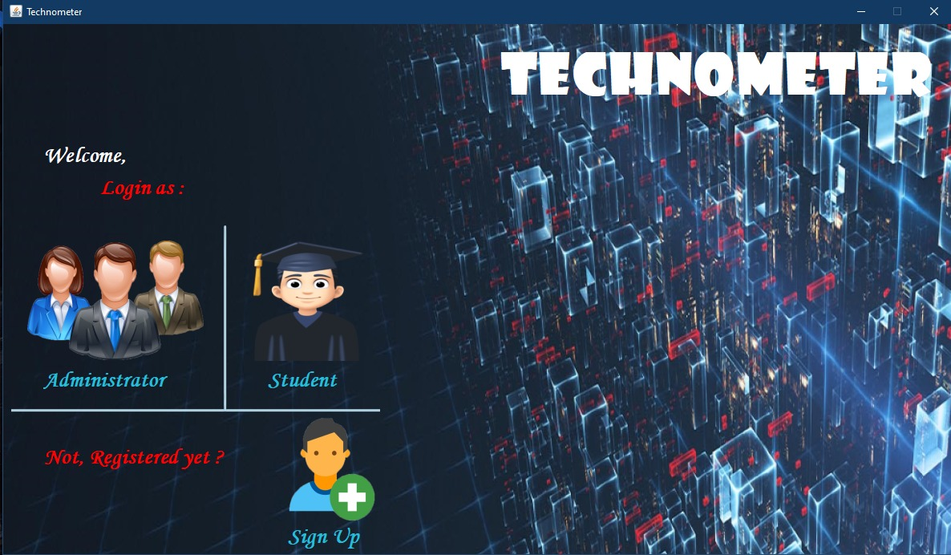

1. **Admin :**

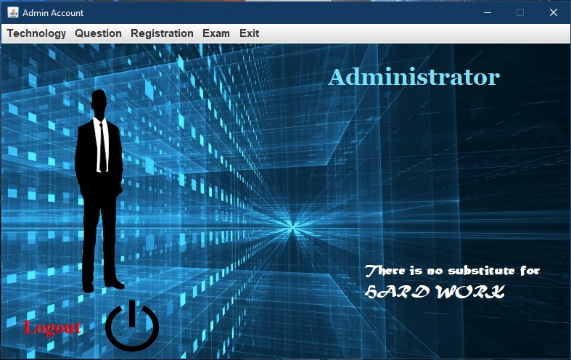

1. **Student:**

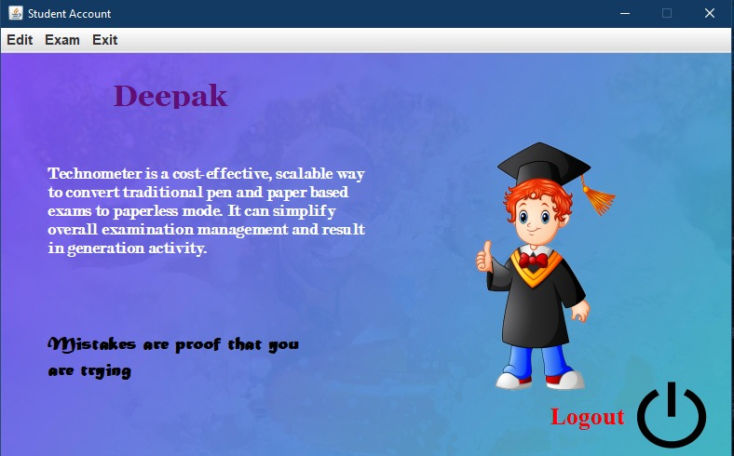

1. **New Technology:**

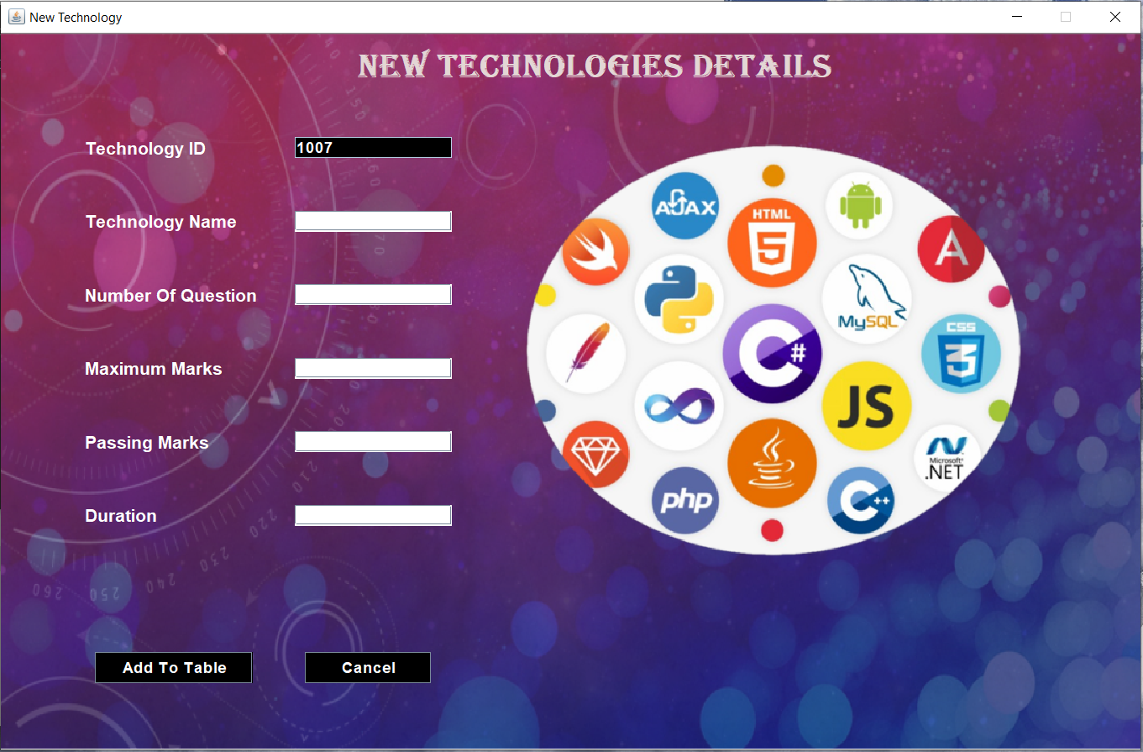

1. **Modify Technology:**

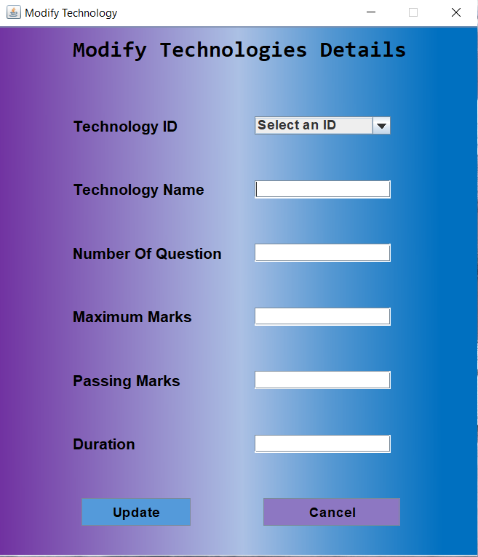

1. **Delete Technology:**

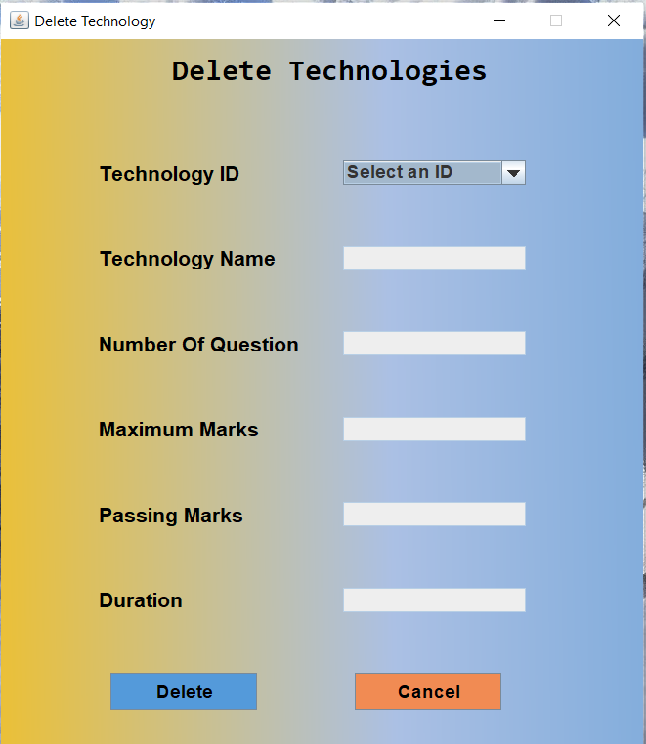

1. **New Question:**

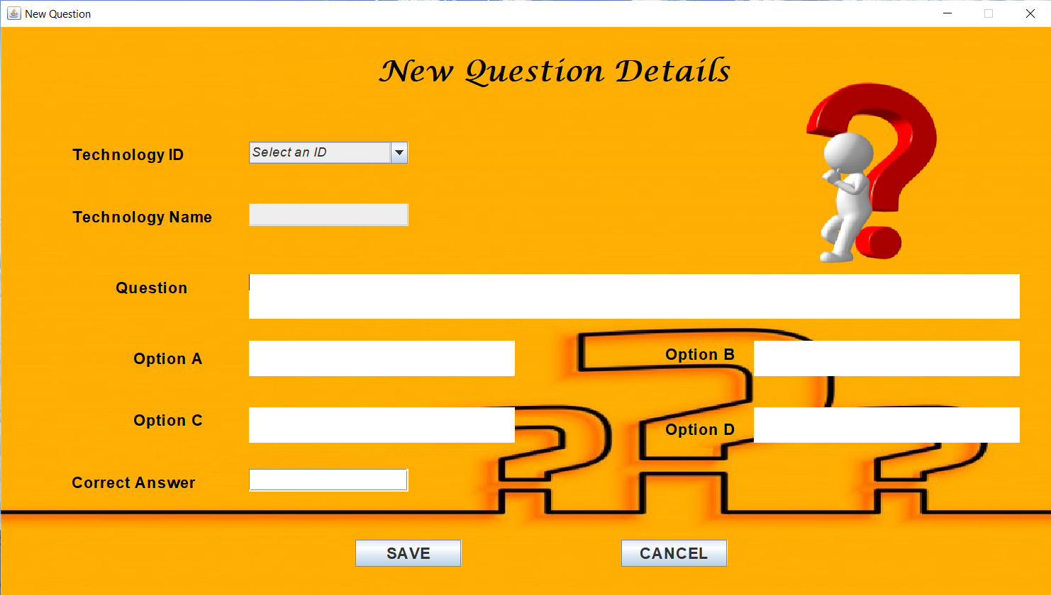

1. **Modify Question:**

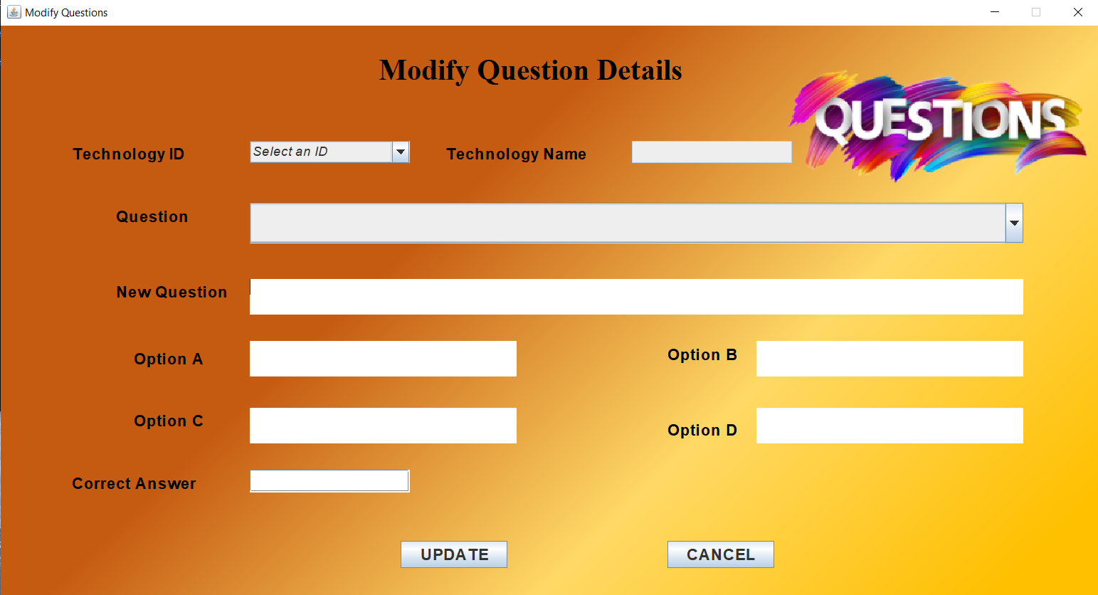

1. **Delete Question:**

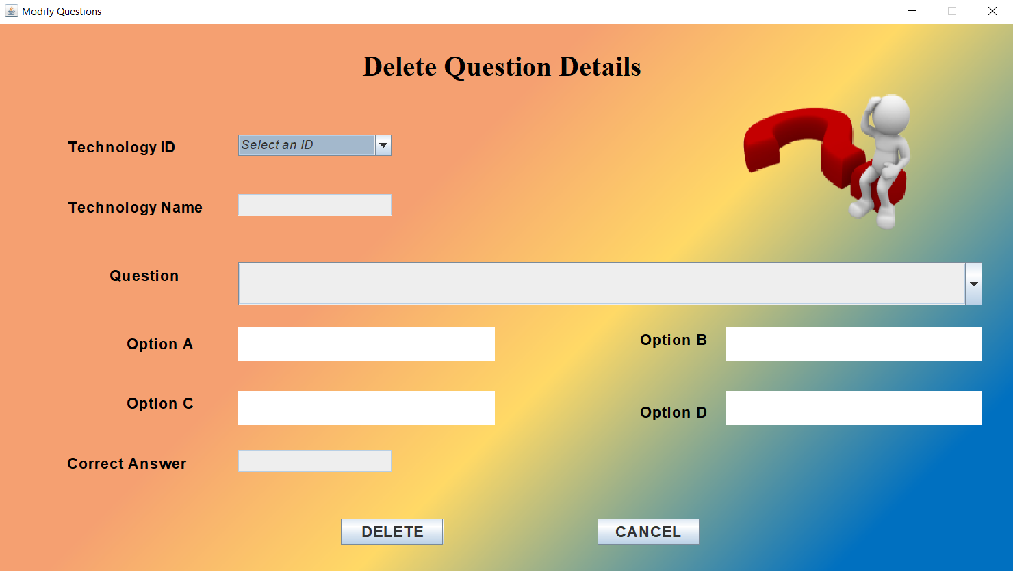

1. **New Registration:**

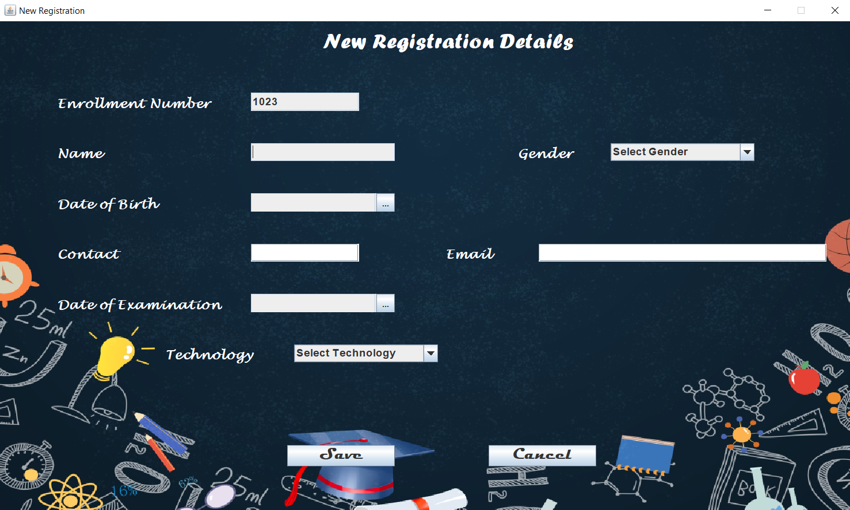

1. **Modify Registration:**

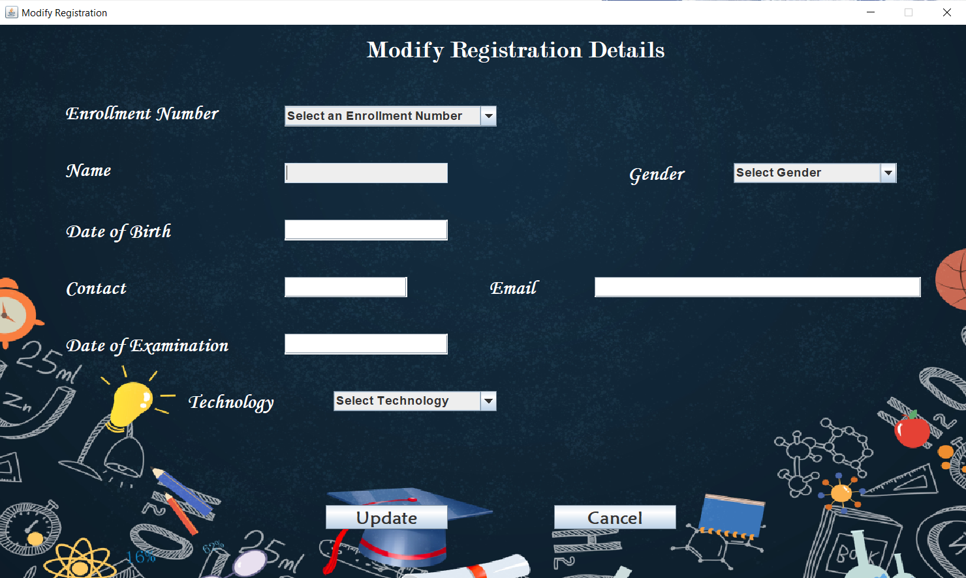

1. **Delete Registration:**

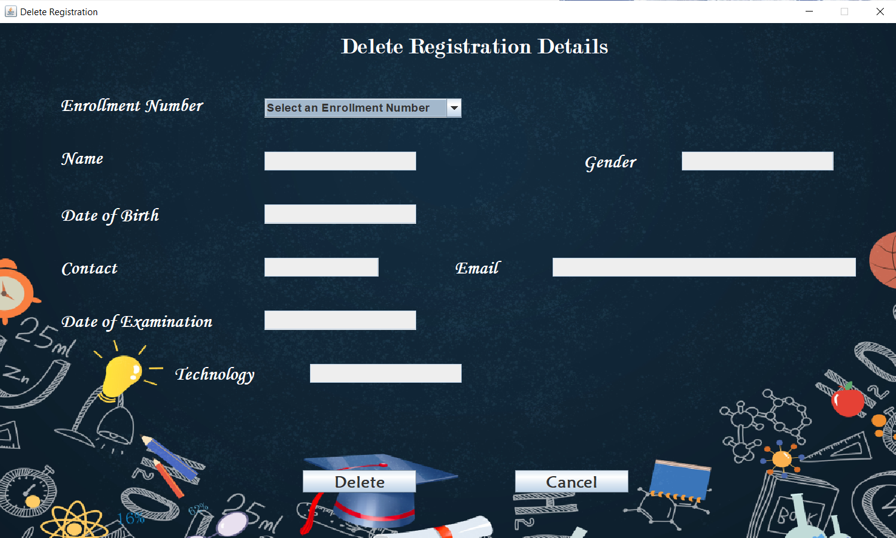

1. **Examination:**

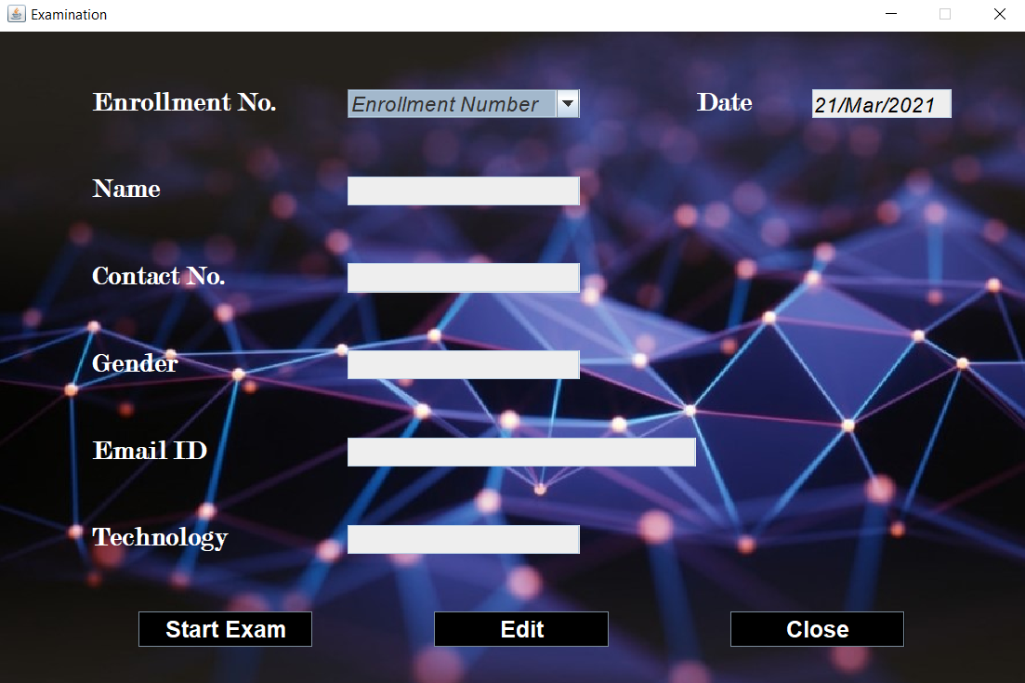

1. **Instructions:**

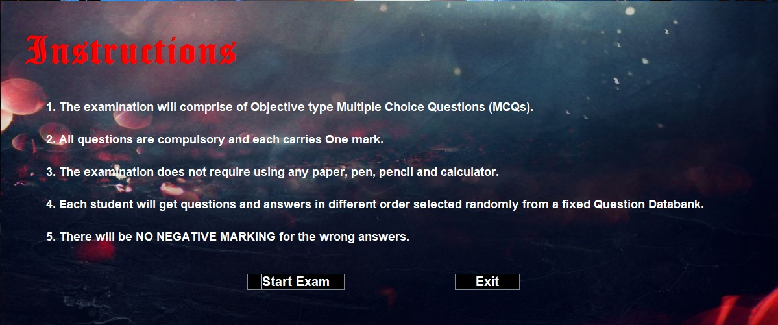

1. **Exam:**

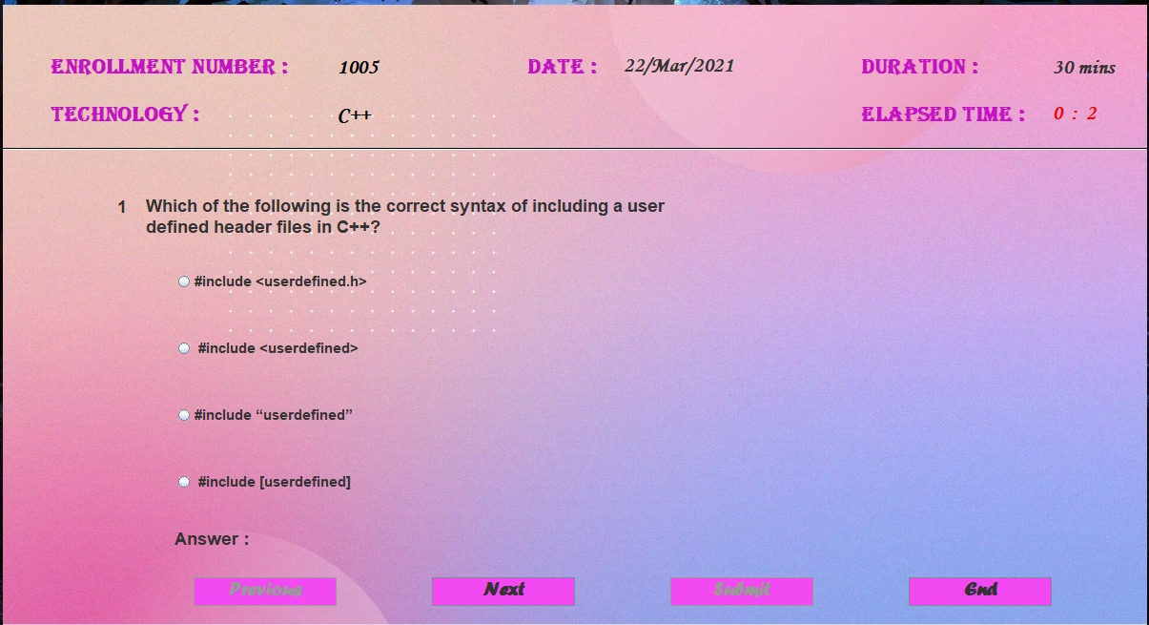

1. **Result (Of students):**

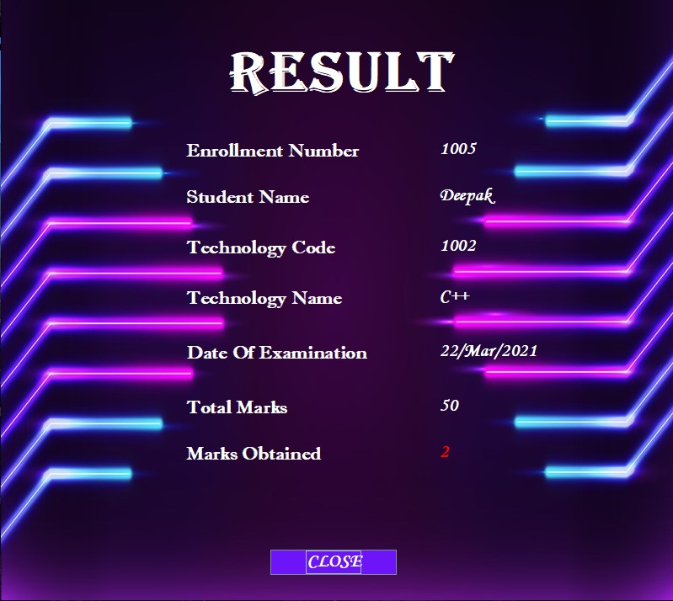

1. **Result (All students):**

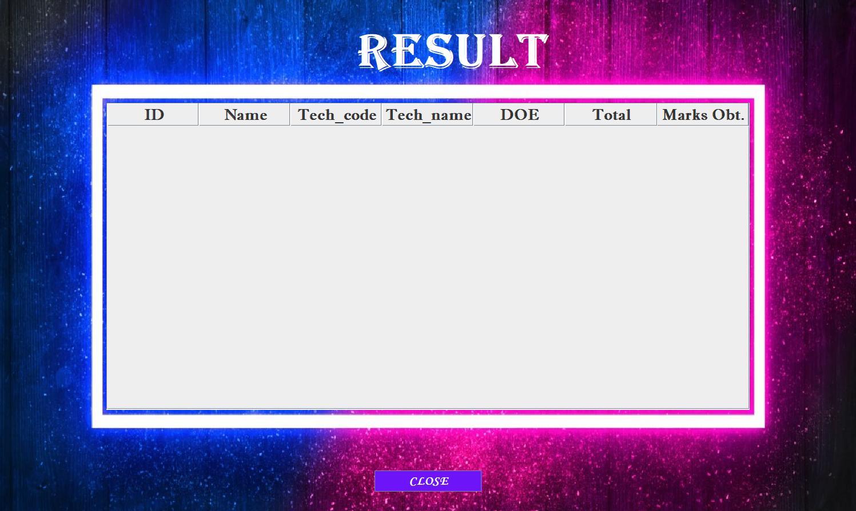

**Testing:**

1. While entering the data, the words overflowed the Text Field boundaries. And hence the information was not visible properly.

To resolve this issue, we used setLineWrap(true) method.

1. Radio Buttons were not visible completely.

To resolve this issue, we use setOpaque(false).

1. While entering the date in Date of Birth, user was able to enter the date in any format. No particular format was there.

We used a calendar, to get accurate date from the user.

1. Registration ID had to be entered by the user manually. This could have created duplicity. Since Registration ID is a Primary key, it cannot have redundancy.

To resolve, we generated the Registration ID automatically.

1. Using a variable from one program to another created complications.

To resolve the complications, we use the ‘Message Passing’ Feature of ‘Object Oriented Programing System’ (OOPS).

1. While working on the JPanel, components were added miscellaneous.

So, we set the Layout to Null through setLayout(null).

1. To get input of date, we used the date picker, but while retrieving, it didn’t set on the date picker and the calendar.

So, we used Text Field instead of JDatePicker.

1. Setting Bounds of the Images and Icons were not possible.

So, we compressed the size according to our requirements and then added it on the frame.

**Limitations of the Project:**

* Skipping of Question is not possible.
* The transaction of examination is done in Offline mode.
* Questions are not randomly chosen. So every time the questions sequence will be the same.
* No Admin can be created or deleted through the Application. It can only be done directly from the database through the Database Administrator.
* No option for Password recovery is provided. Again, it can only be done with the help of Database.
* Scores are stored “Data-wise” not “Time-wise”. So, whenever a student attempts the exam more than once, his/her scores will be stored more than once for the same day.
* While attempting questions, the radio button doesn’t loses the focus on the previous selected option.
* The student can only use previous button only once on every question.

**Future Scope of the Project: -**

This is the modern era of technology where everything become online. Internet is connecting more people at a faster rate than ever before. As we know that, many of the coaching institutes and learning centers are also developing interest in conducting online test through the online examination software for their students instead of pen & paper-based exam. It will conduct the exams at ease. It also provides staff arrangement and less administrative duties and it will also provide a global connectivity to the concerned organization. It clearly proves that the online examination software is the future of assessment methodology.

**Bibliography: -**

* Books:

Core Java

Java: A Beginner’s Guide

Effective Java

* Websites:
* Google for problem solving
* [www.tutorialspoint.com](http://www.tutorialspoint.com)
* [www.w3schools.com](http://www.w3schools.com)
* [www.GeekforGeeks.com](http://www.GeekforGeeks.com)
* [www.tutorialspoint.com](http://www.tutorialspoint.com)